Contents

Screenshots 3

Acknowledgement 4

Abstract 5

**Chapter1. Introduction** 6

1.1 Project Introduction 6

1.2 Background of the project 6

1.3 Overview of the Project 6

1.4 Feature of the Project 6

1.5 Aims 7

1.6 Objectives 7

**Chapter 2: Analysis** 8

2.1 Introduction to Analysis: 8

2.2 Analysis Methodology: 8

2.3 Feasibility Study 13

2.4 Requirement Analysis 15

2.4.1 Functional Requirements 15

2.4.2 Non-functional Requirements 16

2.4.3 Hardware/Software Specification 20

2.4.4 MoSCoW Prioritization 20

2.5 Use-Case Diagram 22

2.6 Natural Language Analysis 25

2.7 Initial Class Diagram 26

**Chapter 3: Designing** 27

3.1 Introduction to design 27

3.2 Structural Modelling 28

3.2.1 Final Class Diagram 28

3.2.2 Context Diagram 30

3.3 Behavioral Model 31

3.3.1 Activity Diagram 31

3.3.2 Sequence Diagram 36

3.4 Database Modelling: 40

3.4.1 Entity Relationship Diagram: 40

3.5 Architectural Model 42

3.5 Prototype Design 43

**Chapter 4: Implementation** 46

4.1 Introduction 46

4.2 Programming Language 46

**Chapter 5 Testing** 130

**Chapter 6 Other Project Issues** 134

6.1 Issues during the Project 134

6.2 Risk Management 135

6.3 Configuration Management 137

6.4 Future Work 138

6.5 User Manual 139

**Conclusion:** 143

**References** 144

# Screenshots

Screenshot 1: Rich picture of Admin 9

Screenshot 2: Rich picture of User 9

Screenshot 3: Conceptual model of Admin 11

Screenshot 4: Conceptual diagram of User 11

Screenshot 5: Overview of Soft System Methodology 12

Screenshot 6: Human and technical aspects integration 13

Screenshot 7: Feasibility Study table 15

Screenshot 8: Functional requirements table 16

Screenshot 9: Non-functional Requirements Table 19

Screenshot 10: Hardware and software specification 20

Screenshot 11: MoSCoW prioritization of functional requirements 21

Screenshot 12: MoSCoW prioritization of Non- functional requirements 22

Screenshot 13: Admin Usecase diagram 23

Screenshot 14: User usecase diagram 24

Screenshot 15: Initial Class Diagram 26

Screenshot 16: Final Class Diagram 29

Screenshot 17: Context Diagram 31

Screenshot 18: Registration Activity diagram 33

Screenshot 19: Expense Activity Diagram 34

Screenshot 20: Income Activity Diagram 34

Screenshot 21: Report Activity Diagram 35

Screenshot 22: Income Sequence Diagram 37

Screenshot 23: Expense Sequence Diagram 38

Screenshot 24: Report Sequence Diagram 39

Screenshot 25: Entity Relationship Diagram 40

Screenshot 26: Architectural Model 42

Screenshot 27: Prototype Design 45

Screenshot 28: Location for Git Push 137

# Acknowledgement

To present the project of Expenses Management System based on subject called Computing Project (CP) and module called Level 5 diploma in computing (L5DC) provided me a great experience. I have gain a lot knowledge with experience from Expenses Management System while doing assignment of Computing Project (CP).

It will utilized for business purposes or for individual person to review their costs or expenses. It helps to recognize and analyze the overall expenses of clients and it will provides opportunities in case of cost saving and control the flow of excessive spending expenses.

Mr. Sudeep lal Bajimaya helps me a lot to complete my Expenses Management System project. So I would like to thanks Mr. Sudeep Bajimaya for proper guiding me on the way of project. It helps to recognize and analyze the overall expenses of clients and it will provides opportunities in case of cost saving and control the flow of excessive spending expenses. I have used android and java programming language to develop an app called expenses management system.

While doing the project I have gain knowledge on android and java programming language and get skills on managing time and resources.

# Abstract

Expenses management system is an android application that help to manage our daily expenses based on income. The main aim of this project is to develop an application where a user can add, update and track income and expenses and to control the excessive money spending of user. Clients can add their salary and their day-by-day expenses to maintain or control the flow of daily excessive expenses this will automatically help in saving purposes.

In this application user can add their income amount, expenses amount and date. They also add and edit their category for income and expenses. To know about the saving user can get report after adding income and expenses amount.

For this project, I have chosen waterfall methodology. Waterfall methodology is easy to implement on project and it is mainly for small project. For proper guiding the coding portion of my application, I have used MVC pattern that helps to manage and fix the bugs easily. I have used three-tier architecture, which helps me in UI designing, provide business logics and database management system. To store the data of user I have used firebase and SQLite database.

# **Chapter1. Introduction**

## 1.1 Project Introduction

Expenses Management System is the name of my project. It will utilized for business purposes or a person to review their costs or expenses. This project enable clients to enter their salary and their expenses according to their needs. The main purpose of this project is to enable the spending thoughts of client’s expenses. It helps to recognize and analyze the overall expenses of clients and it will provides opportunities in case of cost saving and control the flow of excessive spending expenses.

## 1.2 Background of the project

People intended to live their life in smart way in present technological era. Clients enable to register and then login accordingly in expenses management system. Here clients able to add their salary and their day-by-day expenses to maintain or control the flow of daily excessive expenses this will automatically help in saving purposes. This project will help to manage cash flow. In order to finish this project, time should managed properly according to the project needs.

## 1.3 Overview of the Project

This project will used for business purposes or a person to record expenses of user. It helps to record how user spend money and their spending habits. Monitor costs all year to augment reasoning’s, lower assessable pay and spare your organization cash.

Here I have used different things to complete this project. Some of them are Java (programming language), Android Studio (tool), Android (platform), MVC (pattern), and SQL Lite (database).

The main theme of this project is to user make better money spend decisions with concur expense.

## 1.4 Feature of the Project

Features of the Expenses Management System include following things:

* **Register**
* For register user using their Email Address, Username and Password.
* New information regarding clients will sent to Email.
* **Login**
* For login purpose, user will enter their Username and Password.
* **User will edit their profile**
* Profile of user include Username, Password, Email and many other things that related to user profile.
* User can edit their salary and expenses according to their needs.
* **User will add their income**
* For calculation of salary and expenses user will add their income.
* **User will edit their income**
* If there is increase or decrease in salary user will edit their income according to their needs.
* **User will add their expenses**
* **User will view expenses**
* This feature help user to view the list of expenses.
* Provide information about where the money is going.
* **Report of the expenses**
* User will get report of the expenses by calculating all expenses.
* **Logout**

## 1.5 Aims

* The main aim of this project is to develop application where a user can add, update and track income and expenses and to control the excessive money spending of user.
* To produce efficient, secure spending amount and to deliver cost reports of users.

## 1.6 Objectives

* To perform user based design.
* To develop user-friendly application.
* To manage time according to the user needs.
* To get better software with less bugs, the developed application should tested properly.
* To design different types of diagrams like use-case diagram, activity diagram, sequence diagram etc.
* To illustrate the flow of application with the help of diagrams.
* To perform this project as both individual and business purposes.
* For further support all the system development, development methodology, diagrams should documented properly.

# **Chapter 2: Analysis**

## 

## 2.1 Introduction to Analysis:

Analysis is the phase of the software development life cycle (SDLC) which describes the requirements phase of the project and helps to solve the problem arises among clients. Requirements specification is the final product at the end of this stage. By outlining the goals and without considering the implementation of project, requirements gathered with the help of user interaction.

In spite of the fact that requirement gathering is the main aim of this stage, analysis focuses on:

* Information should be gathered and analyzed for feasibility purposes.
* Requirements should be defined and enhance the aims of system
* Requirements should be prioritized and define the alternatives for requirements.
* System Requirement Specification (SRS) should prepared that helps in specification of hardware, software, functional and non-functional requirements of project.
* Conceptual System Design should prepared that helps to give direction for the Management Information System.

## 2.2 Analysis Methodology:

The development team followed a series of structure to develop a system called SDLC. SDLC consists stages like planning, analysis, design, implementation and maintenance of the project. Analysis and Design are the core part of the SDLC. Like SDLC analysis phase also have own techniques and methodologies that helps us to gather user requirements and functionalities of the system that is being developed.

I have chosen **Soft Approach** as an analysis methodology among different other analysis methodology like **People-Oriented, Process-Oriented, Object-Oriented, Hard Approach, Combined Approach** etc.

**Soft Approach:**

Soft Approach for system analysis consists of both technical and human aspects to develop a complete system. This approach based on the people-focused analysis and user-interaction acts as an important technique. The consideration of human, social activity and technical functional requirements belongs into this approach.

Following are the number of steps undertaken while using this methodology:

1. **Human activity analysis of soft approach involves rich picture, root definition and conceptual model**

**Rich picture:**

Rich picture is a collection of pictures, symbols, text and many other things that helps to show the relationships, connections and problem arises between these things.

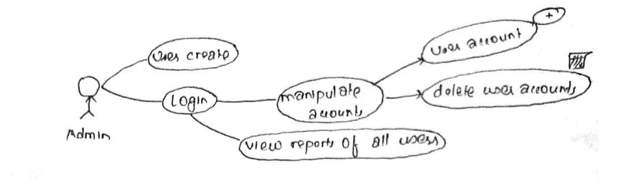

Screenshot 1: Rich picture of Admin

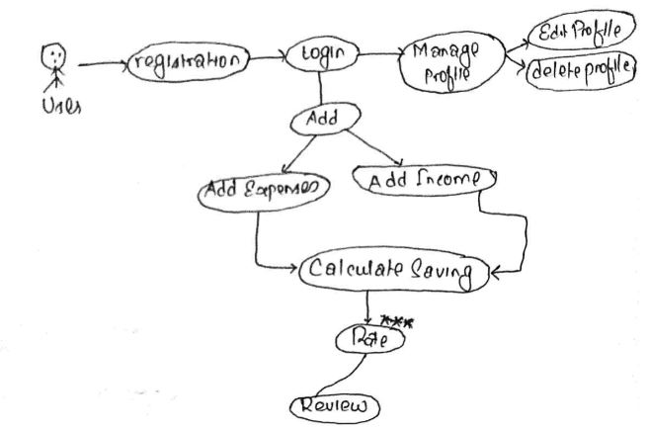

Screenshot 2: Rich picture of User

**Root definition:**

The processes and problem of the system clarify with the help of root definition. There are two types of root-definition i.e.:

Primary task root-definition: focuses on system processes

Issued-based root definition: focuses on problem statement

**WHAT, HOW AND WHY** are the three elements of root definition that defines:

WHAT: defines the aim of the system

HOW: reason for achieving the aim

WHY: longer term aim

**CATWOE** analysis helps to define a root definition.

**CATWOE**

**CATWOE** stands for

**C Customers/Clients**

**A Actors / Agents**

**T Transformations**

**W World View**

**O Owners**

**E Environment**

**Customers** are the important things to run the business. Customers also known as users they accept services through using system**. Actors** must be defined employees, suppliers, agencies and officials. **Transformation** is changes occurred by the system for the easiness of user. **World View** covers the issues arises in the system. Issues may be short-term or long-term. **Owner** is the person who owns the problem they must be the parts of its solution or both. Available resources, budget, laws and regulations comes under **Environment**.

**Conceptual Diagram**

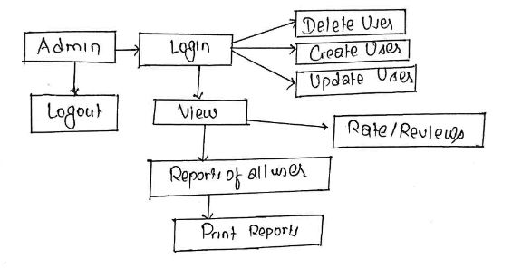The conceptual diagram of expenses management system represented as follows:

Screenshot 3: Conceptual model of Admin

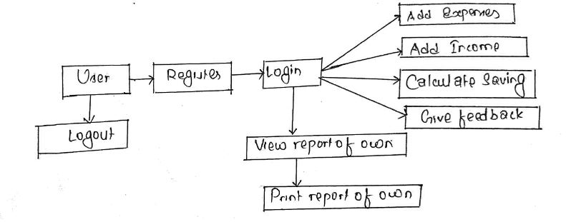

Screenshot 4: Conceptual diagram of User

1. **Social-technical aspects of analysis and design**

Social and technical aspects of analysis and design of Expenses Management System is cover by **Feasibility Study,** which is describe in another portion**.**

1. **Human-Computer Interface design**

To remove duplication of data and diagram human-computer interface design of Expenses Management System is used.

1. **Design of technical aspects**

Technical aspects of Expenses Management System cover System Requirement Specification (SRS). System Requirement Specification (SRS) portion of the project described in another part.

1. **Cultural aspects**

Cultural aspects represents the cultural beliefs and practices of the society. Beliefs of the society do not effect with the use of this application.

1. **Political aspects**

The application that we will develop does not effects the politics policies of the country. Before to develop this application we have to know the political policies of the country.

**Overview of the Soft System Methodology:**

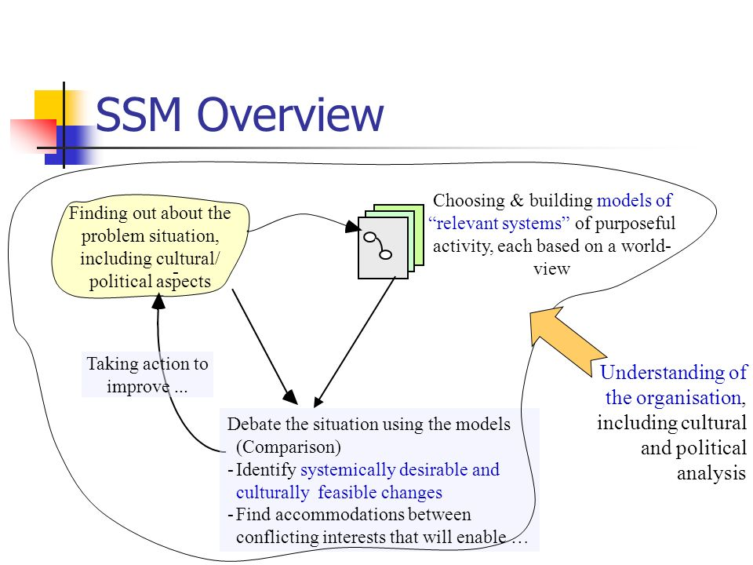

Screenshot 5: Overview of Soft System Methodology

Above screenshot represents the overview of the soft system methodology. The problem arises due to cultural and social aspects is manage with the use of this methodology. Human interaction is an important factor to control the problem. In addition, human interaction managed the misunderstanding between developer and users. For sustainable running this application and to build trust between users and developer, human interaction plays important role.

**Advantages of Soft Approach over other Methodology and its areas of focus:**

I have chosen this methodology because this methodology consider both human and technical factors of the system. Following are the reasons to choose soft approach over other approach are:

* This methodology cover the human, technical, cultural and political part of the system analysis.
* User participation involved during the analysis and design phase of the system.
* To get more user-friendly application user’s knowledge and skills taken as an input parameter for analysis proposes.
* This methodology provides cooperation and stakeholder’s participation to develop complete system.

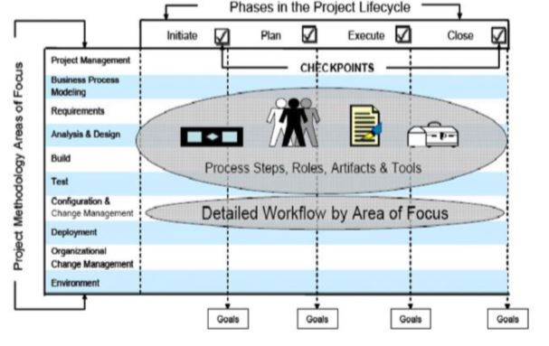

Screenshot 6: Human and technical aspects integration

## 2.3 Feasibility Study

The real world scenario in which a proposed system is financially, technically and operationally practical and workable called feasibility study. Feasibility study comes under social and technical aspects of analysis and design and covers description of product, financial data, legal requirements, tax obligation and many more.

Types of feasibility study and their relation with Expenses Management System are:

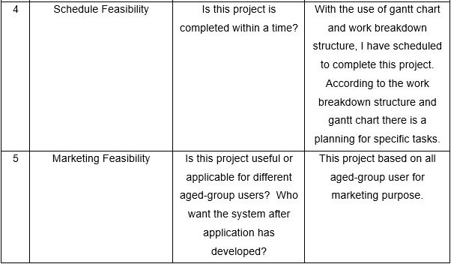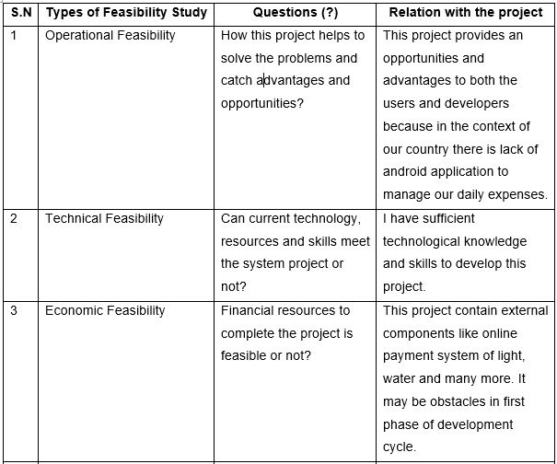

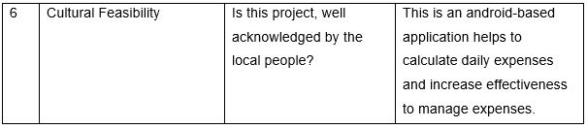

Screenshot 7: Feasibility Study table

## 2.4 Requirement Analysis

Requirement analysis is the hardest part of building a software system. The goal of requirement analysis is to understand the requirements of user’s and documented them properly. Requirements of users include functional and non-functional requirements that implemented in a system.

## 2.4.1 Functional Requirements

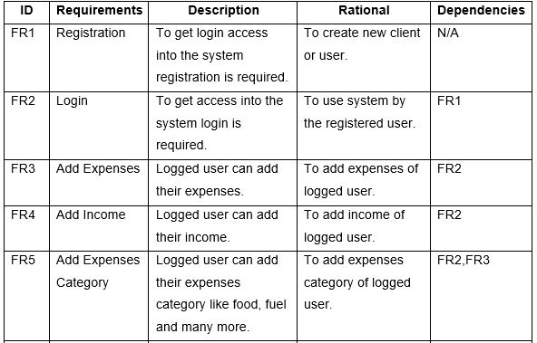 Functional requirements define all the services or functions required by the users they must have provided by system. Functional requirements are easy to test in comparison to non-functional requirements. It describes “what” the software should do. It related to the individual system features. Failure to meet the individual functional requirement may degrade the system. Functional requirements of Expenses Management System described as follows:

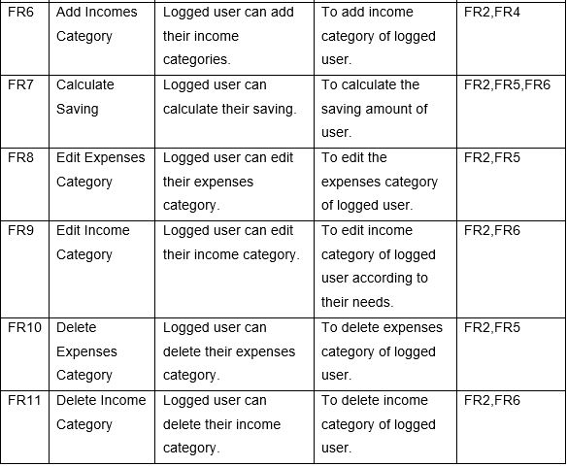

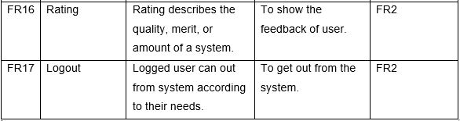

Screenshot 8: Functional requirements table

## 2.4.2 Non-functional Requirements

Non-functional requirements define the system properties and constraints. Non-functional requirements are difficult to test in comparison to functional requirements. . It describes “how” the software will do it. It related to system as a whole. Failure to meet non-functional requirements may make the system unusable.

Non-Functional requirements of Expenses Management System described as follows:

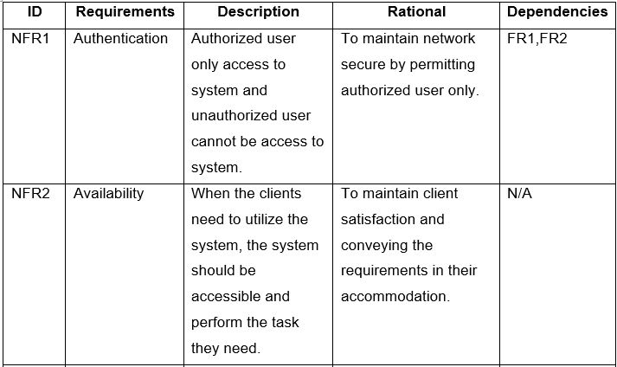

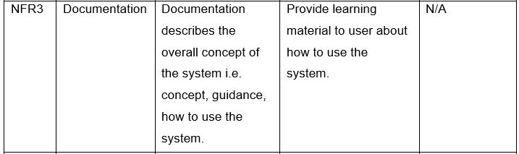

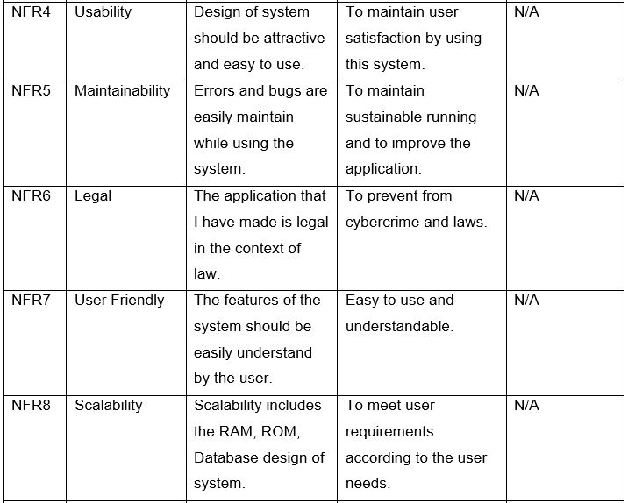

Screenshot 9: Non-functional Requirements Table 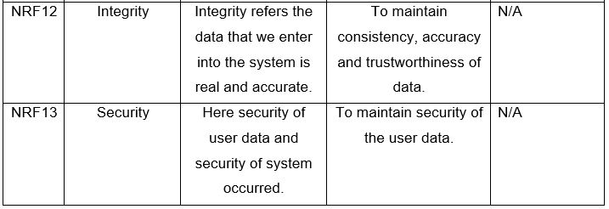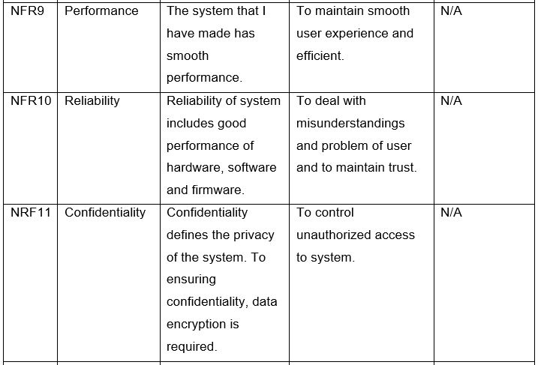

## 2.4.3 Hardware/Software Specification

The application that I have been developing requires following hardware/software specification:

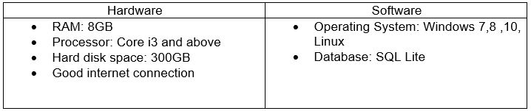

Screenshot 10: Hardware and software specification

## 2.4.4 MoSCoW Prioritization

I have chosen MoSCoW requirement prioritization to prioritize the functional and non-functional requirements of Expenses Management System among different requirement prioritization like grouping assignment, ranking, bubble sort technique, Analytic Hierarchy Process, hundred dollar method.

Due to the time and budget stakeholders does not meet their requirements. Prioritization of requirement occurs to satisfy stakeholders. MoSCoW stands for Most have (M), Should have (S), Could have (C) and Would have (W).

**Must have (M)** - Vital requirements for the project i.e. system cannot perform without those requirements.

**Should have (S)** - Requirements considered as important but not vital. If we have remaining time it can added in future.

**Could have (C)** – Requirements that considered as desirable but not necessary

**Would have (W)** - A requirement that cannot be implemented in current version due to the lack of time and resources, but may be considered in future.

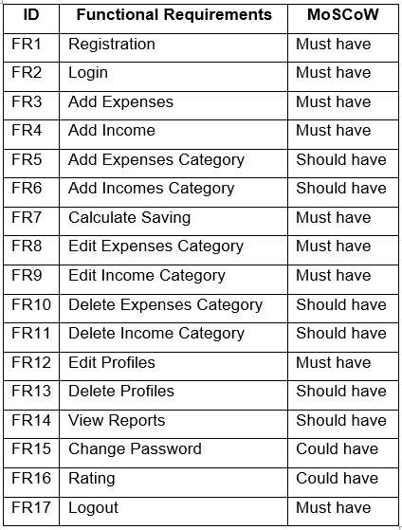

Screenshot 11: MoSCoW prioritization of functional requirements

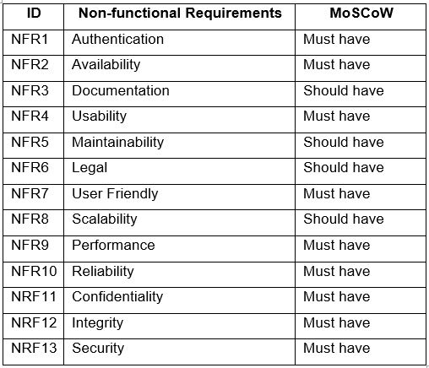

Screenshot 12: MoSCoW prioritization of Non- functional requirements

## 2.5 Use-Case Diagram

In UML, a use-case diagram is also known as dynamic or behavioral diagram. A use-case diagram shows the set of use-cases, actors (special kind of class) and their relationship in graphical way. To manage the system requirements i.e. identify, simplify and organize use-case diagram plays important role during analysis. (Ivory-Ndiaye, 2018)

In object modeling and real-world system it has own standard notations. They are boundary, actors, use-cases and relationships.

**Advantages of Use-Case Diagram:**

* Functional requirements of the project gather in use case diagram.
* Use-case diagram gather additional behavior of system and improve in system robustness.
* It describes that how the actor connect with system.
* It can provide the summary of the whole system.
* During requirement gathering this diagram is good choice for system analyst because it is easy to draw and easily understandable.

**Disadvantages of Use-Case Diagram:**

* Use-case diagram cannot gather the non-functional requirements of the product.
* Some products and system have complexity to write and understand the diagram for both developers and users.
* 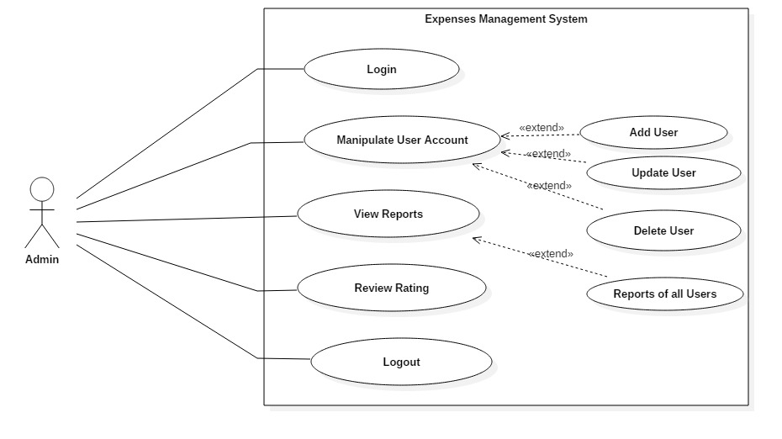It only summarized the relationship between cases, systems and actors.

Screenshot 13: Admin Usecase diagram

**Scenario Description**

Actor: Actor represents Admin

Admin can access to overall performance of the system. According to the diagram, Admin can perform following things:

* Admin can access to login into system of all user.
* Admin can access to manipulate user account. Manipulation of user account includes Add User, Update User, and Delete User etc.
* Admin can access to view reports, review and rating of all user.
* Admin can logout from system.

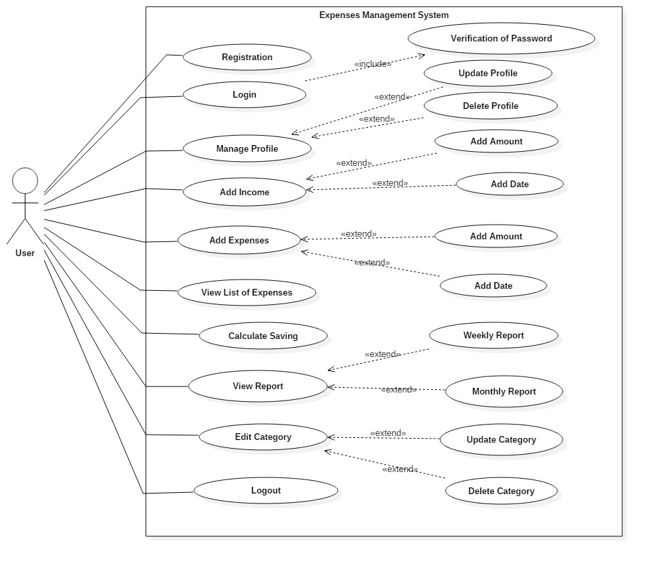 **Scenario Description**

Screenshot 14: User usecase diagram

Actor: Actor represents User.

User can access to following things of system:

* User can register to login into the system.
* User can login to use system.
* User can manipulate their own profile. Manipulation of the profile include Update Profile and Delete Profile.
* User can add their income and expenses.
* User can view their list of expenses.
* User can calculate their saving with the use of expenses and income.
* User can view their own report.
* User can edit their own category like food, clothes, hospital etc.
* User can logout from system.

## 2.6 Natural Language Analysis

Expenses Management System is an android application that helps to manage your expenses and calculate saving of income. Reducing paper work, saving time and money is the main aim of this project. It also helps to reduce human errors and provide satisfaction to the user.

This project consists of two actors i.e. Admin and User. The database of this project stores user’s data. User data includes Id, First name, Last name, Email, Password, expenses of user, category of expenses, income of user, category of income and many more. System also includes review and rating of user towards application. Future plans of application based on review and rating from the users.

The system provide many features to the user with proper access control like Login, Registration, add date, expenses and income. User can able to enter into the system after registration and access to manipulate their own account. Manipulation of account include add, edit, update and delete their own personnel profile and data.

Natural Language Analysis is a process to separate noun, adjective and verb from the scenario.

* Noun represents candidate class
* Adjective represents candidate attributes
* Verb represents the operations or methods

Following are the Candidate class, attributes and methods from the Natural Language Analysis:

|  |  |  |
| --- | --- | --- |
| **Noun (Candidate Class)** | **Adjective (Candidate Attributes)** | **Verbs (Candidate Methods)** |
| User, Category, Expenses , Income | First name, Last name, Email, Password | Add, Edit, Update, Delete, Review, Rate |

## 2.7 Initial Class Diagram

The popular UML diagrams and represented by the blue print of a system called class diagram. It shows the relationship and graphical representation between class, object, attributes and methods of a system. Class diagram is directly mapping with object-oriented languages thus it can used widely due to the phase of construction. It also helps in constructing executable code for application.

To draw class diagrams we have used many rectangular boxes with three sections: 1st section of the rectangular box represents the class name of the system, 2nd section represents the attributes of the class and finally third section represents the methods of the class. Association, Aggression and Composition are the components to show the relationship between different classes.

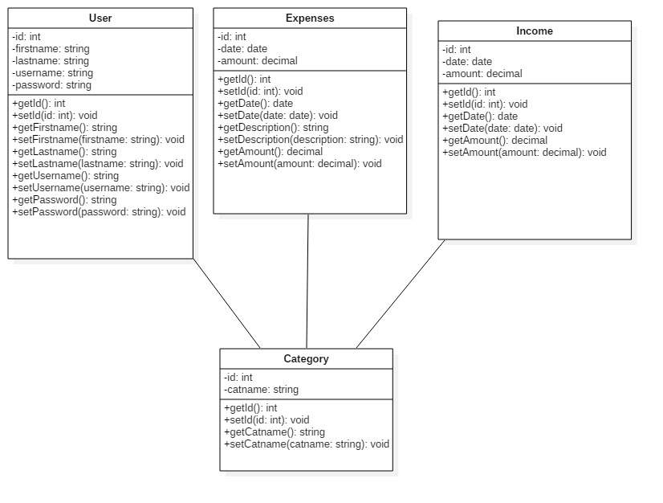

Screenshot : Initial Class Diagram

# **Chapter 3: Designing**

## 3.1 Introduction to design

Design phase plays an important role to build a system. Here we can get the answer of “how” questions, arises during the development of system. GUI part and database design of the system development covered by this phase. To demonstrate the structure and workflow of the system, that is being developed I have used different models like structural model and behavioral model. It gives us an overview of the frontend and backend of the system. Design phase involves different diagrams so that non- technical user can know more about the system. The main purpose of the design phase is to transfer the user requirements into some acceptable form.

## 3.2 Structural Modelling

## 3.2.1 Final Class Diagram

In UML modelling, class diagram shows the relationship between classes, their attributes and operations. Class diagram is the backbone of an OO modelling and referred as blueprint of the system. It is the exception in UML Modelling that class diagram directly mapped with any object-oriented programming languages.

**Justification:**

I have chosen class diagram in comparison to other structural diagram because class diagram visualize, describe and document the different aspects of system. Class diagram is the only UML diagram that can directly mapped with object-oriented languages and it can be widely used at the time of construction.

**Notation used to draw Class Diagram:**

|  |  |  |
| --- | --- | --- |
| Notation Used | Name | Description |
|  | * Top row represents the class. * Second row represents the attributes. * Third row represents the operations. | We have given the name of class in first row, their attributes in second row and operations in third row. |
|  | Generalization | It shows the parent and child relationship called inheritance relationship in object oriented. |
|  | Association | It shows the static relationship between classes. |
|  | Dependencies | It shows the relationship between super class and sub-class. |

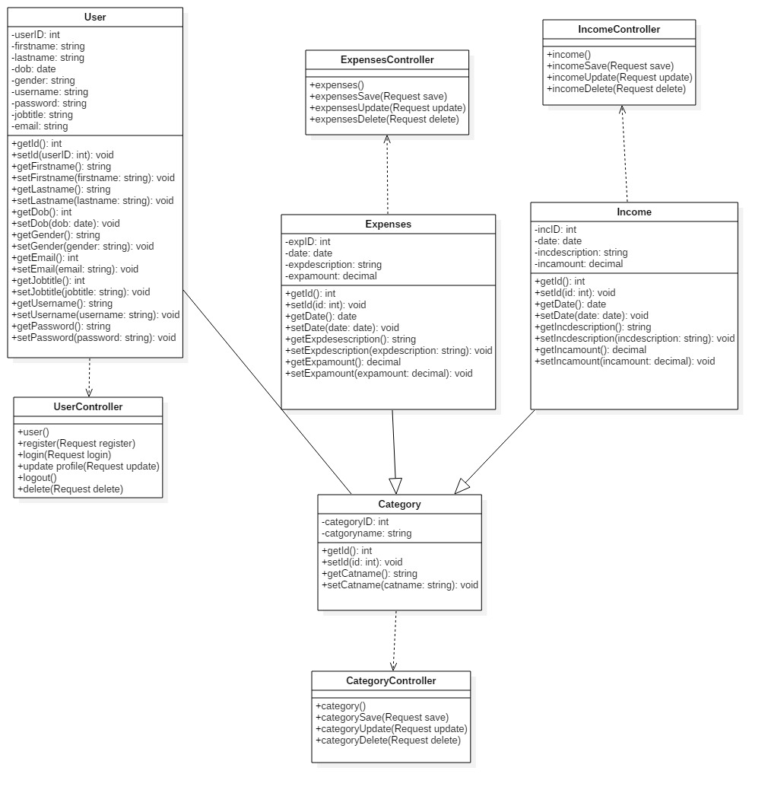

Screenshot 16: Final Class Diagram

**Explanation:**

In design phase, final class diagram of expenses management system has created according to the MVC pattern. In MVC pattern, model is a non-visual object that holds all the data and behavior other than utilized for the User Interface (UI) design. Display of the model (i.e. data or information and behavior) in the User Interface represents View. Changes made to the data or information managed by third member called controller. Above class diagram shows the specific operations with their controller and view.

## 3.2.2 Context Diagram

Context diagram is the part of structural modelling which shows the overview of the complete system. The main purpose of this diagram is to show the expecting input and output values from the system, to and from various external entities. In the context diagram there is only one process to represents for entire system. (LLC, 2018)

**Justification:**

I have chosen context diagram in comparison to other structural diagram because categories of context diagram is unique to other, describe the input, and output process of the system.

Categories of the context diagram include following points:

* Active: Dynamic to accomplish some objectives or reason
* Passive: represents external entities and interaction of those entities with the system
* Cooperative: to release some ideal result with the use of some external entities by the system
* Autonomous (Independent): Autonomous represents those external entities that are being separate from the system and indirectly affect the system by means of forced requirements.

**Notation used to draw Context Diagram:**

|  |  |  |
| --- | --- | --- |
| Notation Used | Name | Description |
|  | External Entity | Input data or retrieve data into and from the information system. |
|  | Processes | Action takes place on data and turning it into information. |
|  | Flow Line | Represents the flow of data (i.e. data is being sent or retrieved) |

**Context Diagram:**

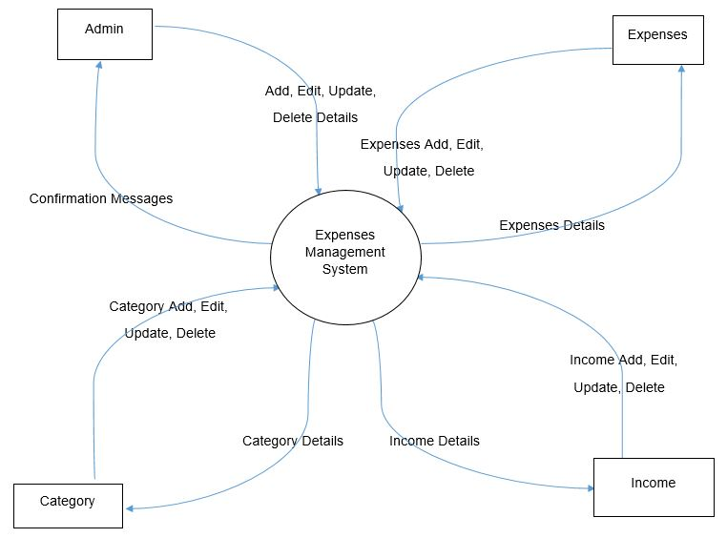

Screenshot 17: Context Diagram

**Explanation:**

Above context diagram represents the overview of the entire system. Admin can easily access into the user account and manipulate their data and returning confirmation message by providing what type of action take place. In case of expenses, income and category we can add, edit, update and delete data of those entities provide returning details message.

## 3.3 Behavioral Model

## 3.3.1 Activity Diagram

In Unified Modelling Language, activity diagram is another important diagram. It describes the dynamic behavior of the system by showing the workflow from one activity to another and also known as operation of the system. (tutorialspoint.com, 2019)

**Justification:**

I have chosen activity diagram in comparison to other behavioral diagram because it shows the flow of activity and describes the sequence of activity from one to another. The main purpose of this diagram is to show the flow of system i.e. parallel, branched and concurrent.

**Notation used to draw Activity Diagram:**

|  |  |  |
| --- | --- | --- |
| Notation Used | Name | Description |
|  | Initial Node | Represents the initial action state. |
|  | Final Node | Represents the final action state or system. |
|  | Activity or Action State | It shows the activity i.e. actions of object. |
|  | Action Flow | It shows the path from one activity to another. |
|  | Decision and Branching | It represents the decision with alternate path. |
|  | Fork Node | It represents the split of single incoming flow into multiple flows parallely. |
|  | Join Node | It helps to join the multiple flows and back them into single flow. |
|  | Sent and Received Signals | Here signal must sent by sent signals and accepts by accepting signals of activity. They usually occurs in pair. |
|  | Flow Final Node | It represents the termination of a flow. |

**Registration Activity Diagram:**

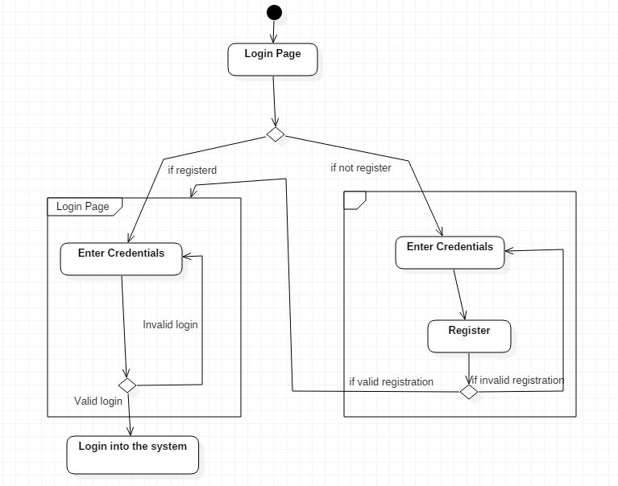

Screenshot 18: Registration Activity diagram

Above diagram shows the activity diagram of registration and shows how to login into the system. User must be registered to use the system i.e. sign up into the system otherwise user cannot get access int the system.

**Expenses Activity Diagram:**

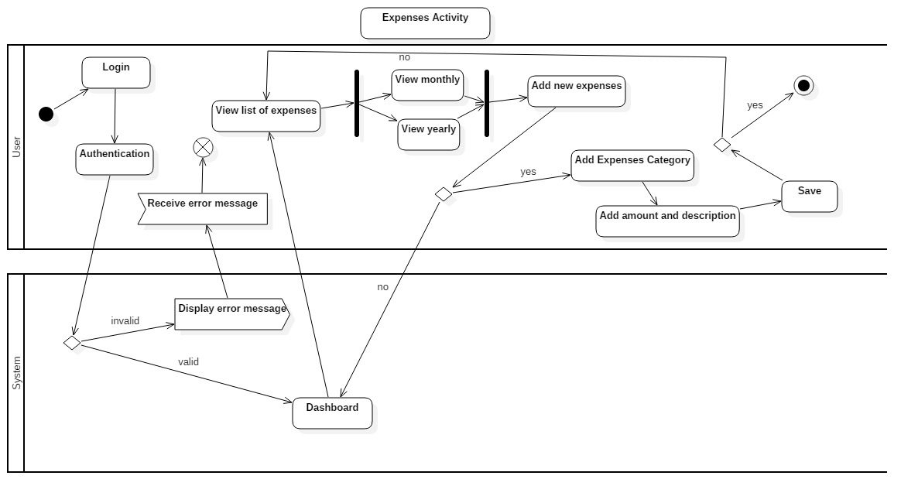

Screenshot 19: Expense Activity Diagram

**Income Activity Diagram:**

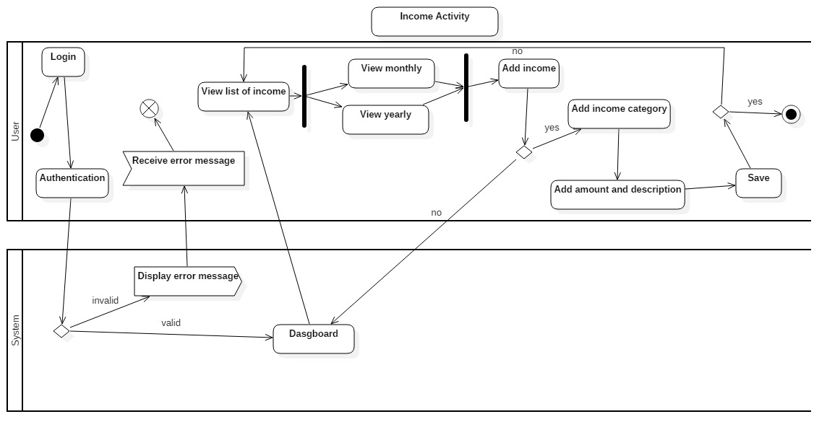

Screenshot 20: Income Activity Diagram

**Report Activity Diagram:**

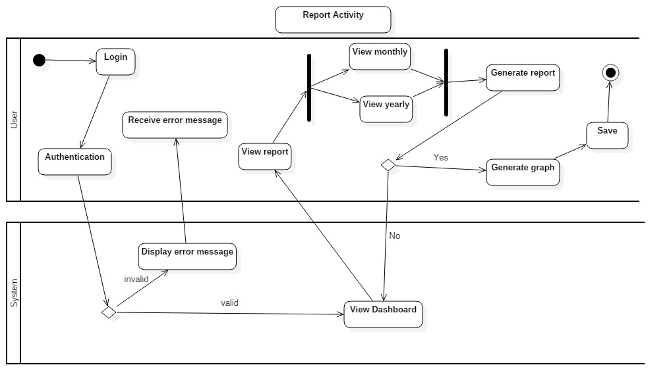

Screenshot 21: Report Activity Diagram

**Explanation of the System Activity Diagram:**

Above diagram (i.e. expenses, income and report activity diagram) shows, the complete flow of activity occurs in a system. After user get registered user can easily access into the system. Then expenses activity of user shows the list of expenses, add expenses, category of expenses and income activity shows the list of income, add income, category of income. Report generated after the activity of expenses and income. Here we can generate monthly and yearly report.

## 3.3.2 Sequence Diagram

Sequence diagram is the special type of interaction diagram, which shows the message communication between various object. The dynamic behavior of the system has captured by sequence diagram. (geeksforgeeks.org, 2019)

**Justification:**

I have chosen sequence diagram in comparison to other behavioral diagram because this diagram helps to describe message flow in the system, structural organization of the objects and interaction among objects.

**Notation used to draw sequence diagram:**

|  |  |  |
| --- | --- | --- |
| Notation Used | Name | Description |
|  | Object | It illustrates class roles but don’t list object attributes |
|  | Activation Boxes | It represents the time of an object needs to complete a task |
|  | Lifeline | It is the vertical dashed lines that denotes the object’s presence over time |
|  | Messages | * Message are arrows that represents communication between objects. * A reply message is drawn with a dotted line and an open arrowhead pointing back to the original lifeline |
|  | Self-Message | A message an object send to itself, usually shown as a U shaped arrow pointing back to itself. It represents recursion. |

**Income Sequence Diagram:**

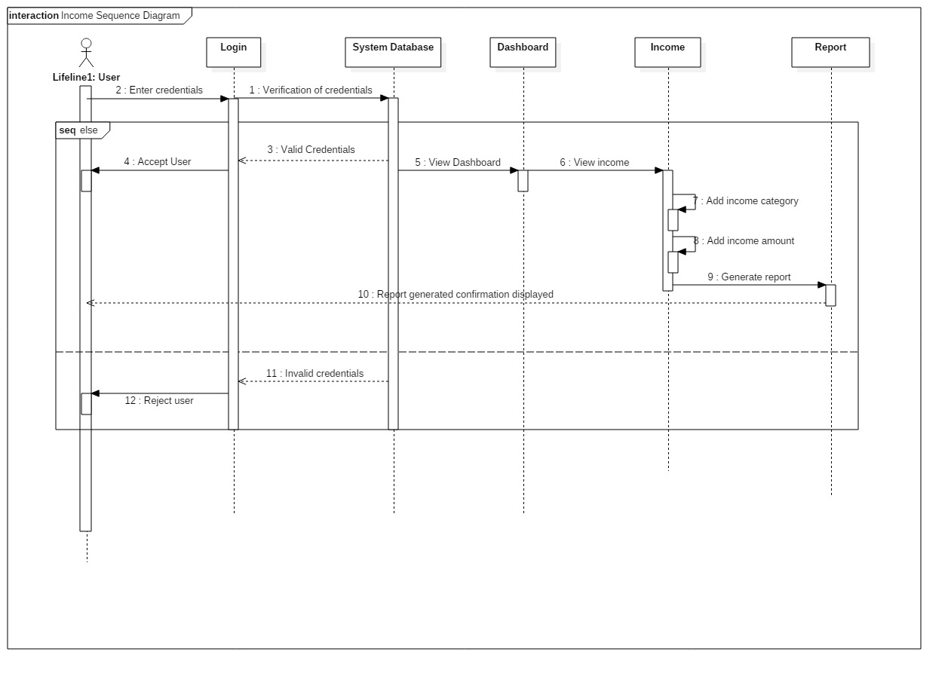

Screenshot 22: Income Sequence Diagram

**Expense Sequence Diagram:**

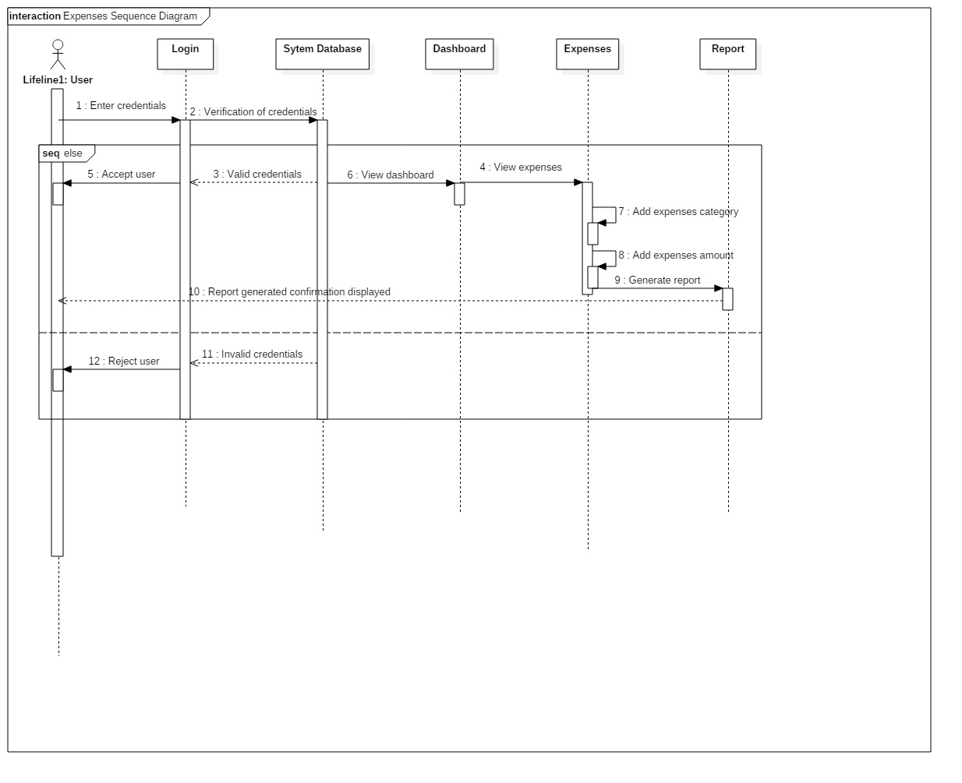

Screenshot 23: Expense Sequence Diagram

**Report Sequence Diagram:**

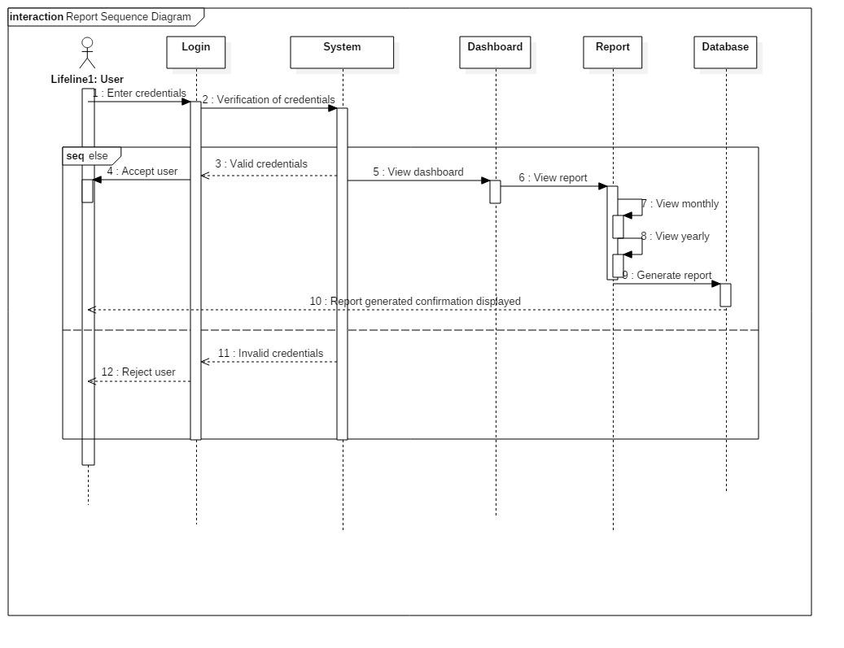

Screenshot 24: Report Sequence Diagram

**Explanation:**

Above sequence diagram shows the interaction between user and system and the flow of message between them. If a user enter the valid credentials then user can get login access into the system. User can add their expenses, expenses category, income, income category and generate report according to their needs. If the entered credentials is invalid then user cannot get access into the system.

## 3.4 Database Modelling:

A database model decides the logical structure of database and fundamentally decides that how the data can be stored, manipulated and organized. Database model includes different models like relational models, hierarchical model, flat files model, object oriented models, entity relationship models and network models. Among them, I have chosen relational model to complete my project.

## 3.4.1 Entity Relationship Diagram:

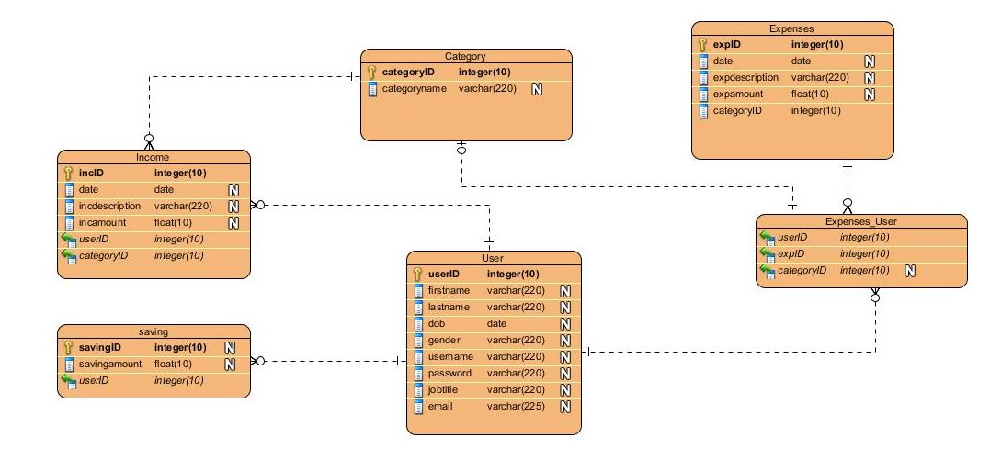 “Peter Chen” developed Entity Relationship Diagram and based on perception of real world in which this diagram describes the visual representation of data by defining how the data related to each other. This diagram consists of collection of object called entities and showing relationship between those entities and attributes. Below ER-Diagram based on the data dictionary.3.4.2 Data Dictionary:

Screenshot 25: Entity Relationship Diagram

A structured place to keep details of the contents of data flow process and data store. It is the structured repository of data about data. Data dictionary provides information about Data Flow, Data Structure, Data Elements, Data Stores and Data Processing.

The main purpose of data dictionary is to reduce data redundancy and for developers it helps to make normalization.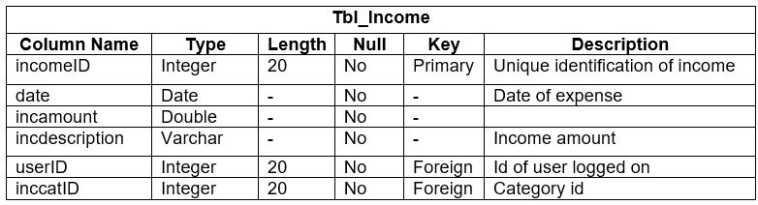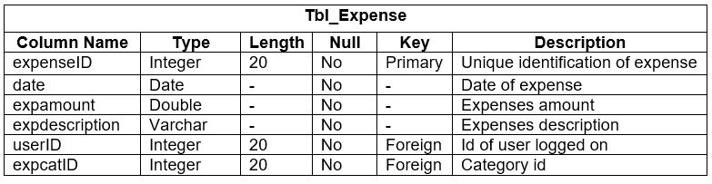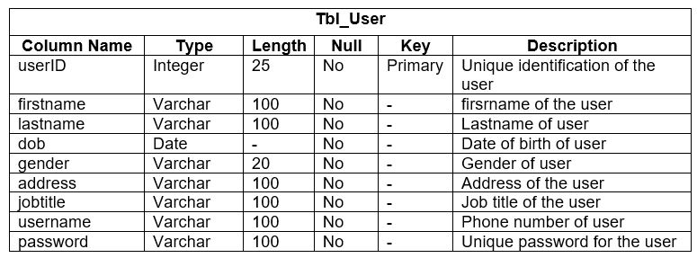

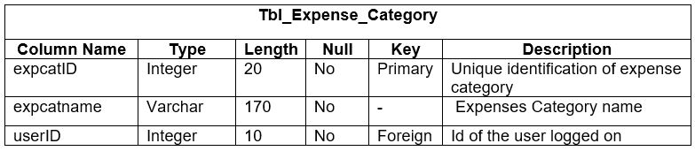

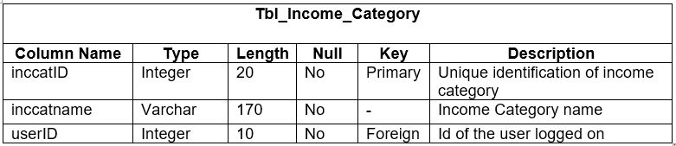

## 3.5 Architectural Model

I have chosen three-tier architecture model in which there are three components:

* Presentation tier
* Application tier
* Data tier

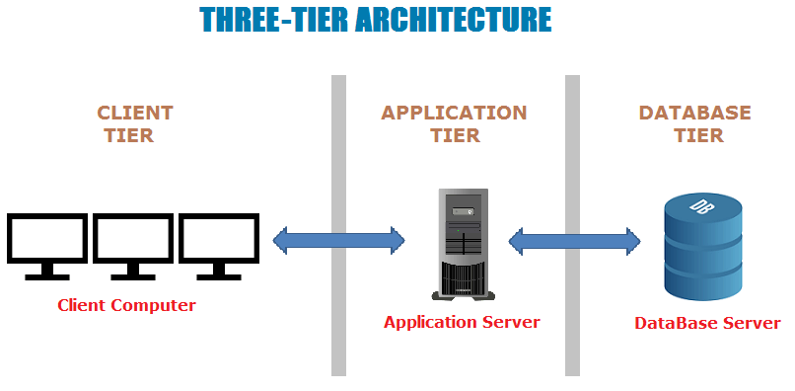

Screenshot 26: Architectural Model

Presentation tier:

Presentation tier occupies the top-level and it displays the information related to services on website or application. It communicates with other tier like server and your database and it sends the result to the browser and other tier in network.

Application tier:

Application tier is also known as middle tier, logic tier and business logic. This pulled from presentation tier and it controls the application functionality by performing and detailed processing. It is the part of program in Computer Software. It encodes the real world business rules and determines how data is going to created, displayed, stored and changed.

Data tier:

Data tier houses the database server where information is stored and retrieved. The data that is kept here or independent of application server we called it as business logic includes data persistent mechanism of database servers and file servers. It also includes Data Access Layer, which encapsulate the data persistence mechanism and exposes the data and should provide API to Application tier so it exposes the method of managing i.e. store data without exposing/creating dependencies on data storage mechanism. Data Access Layer also helps in avoiding dependencies on storage mechanism and allow update and changes without application tier client and it is aware of change.

## 3.5 Prototype Design

It is an important step in design phase and represents as the draft version of an application where we can explore our ideas.

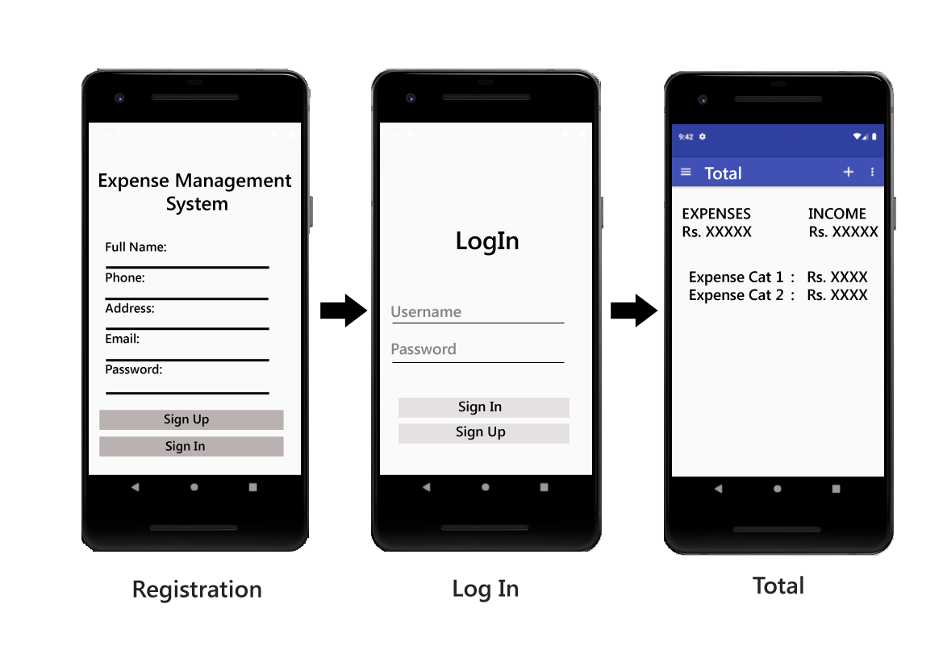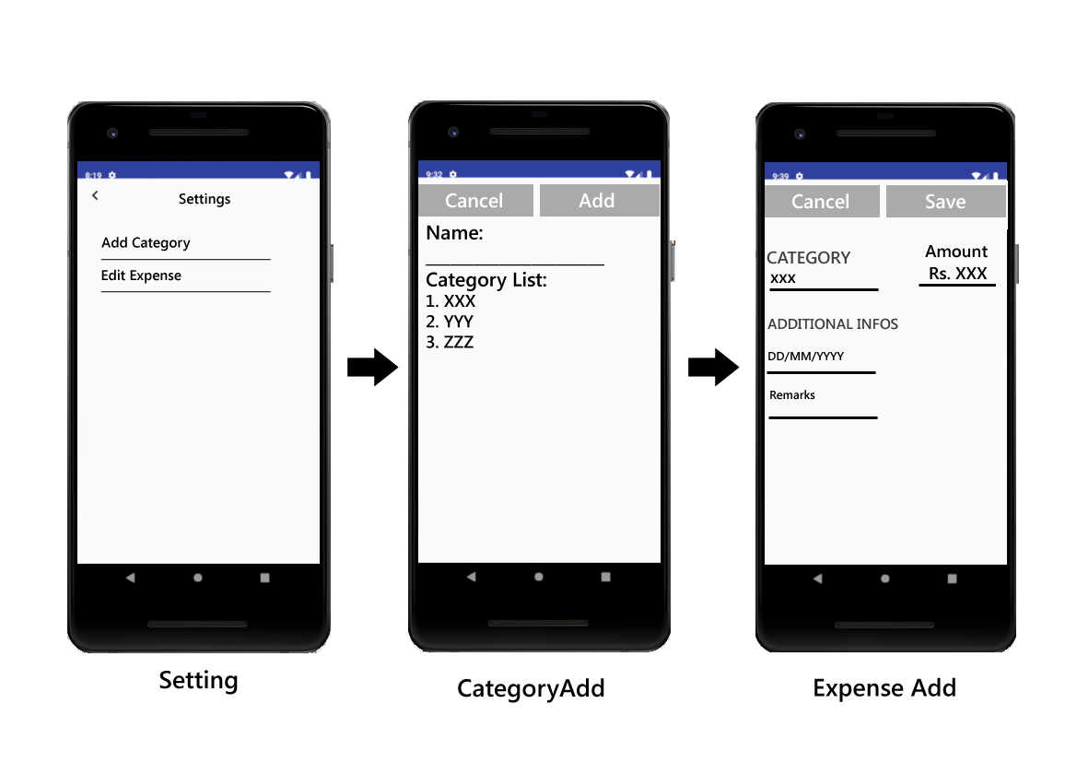

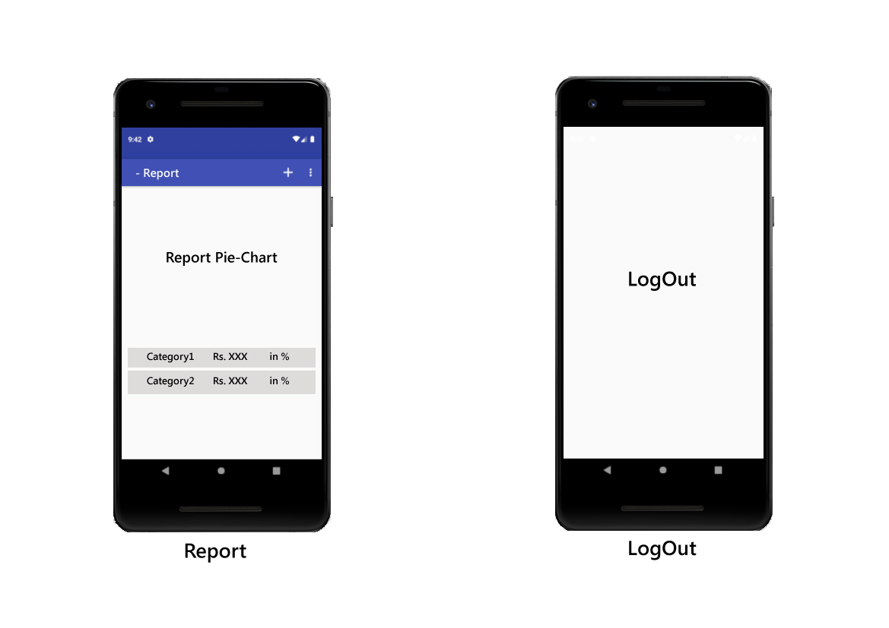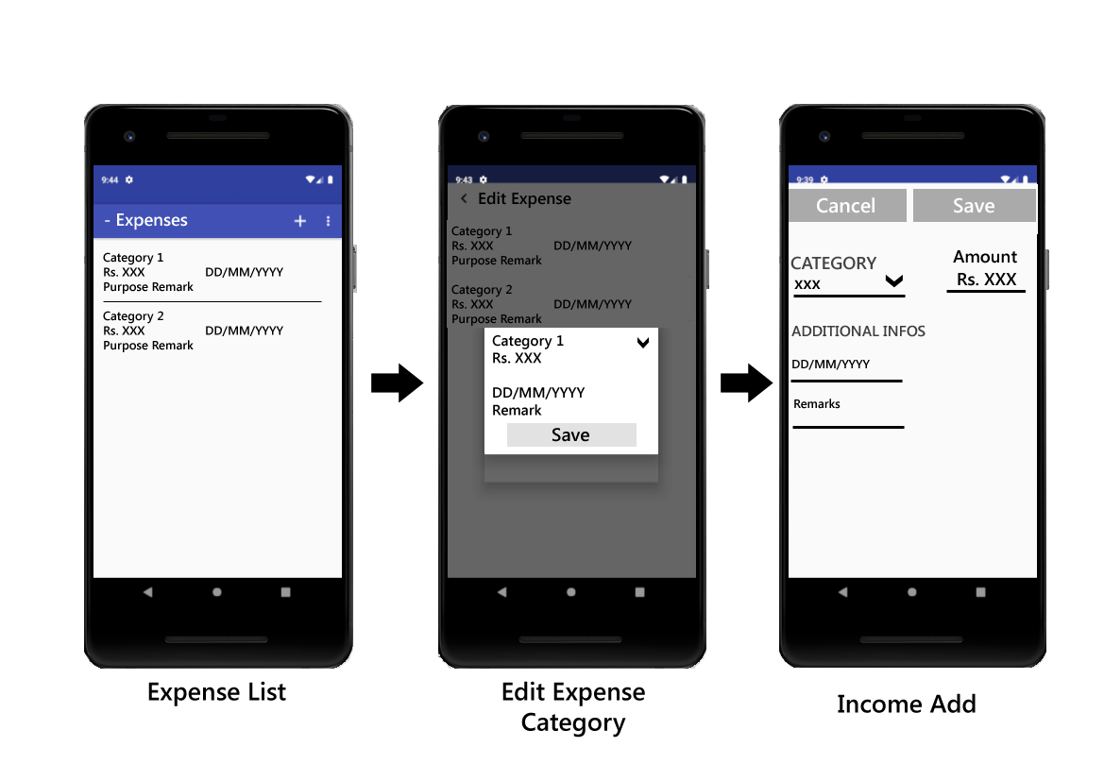

Screenshot 27: Prototype Design

# **Chapter 4: Implementation**

## 4.1 Introduction

After Analysis and Design, Implementation is the 3rd phase of the software development lifecycle. This is the phase in which the execution of plan occurs accordingly and covers the coding portion of the project. Here the project team build the actual product. Implementation takes all possible steps to ensure the upcoming system development and transaction occurs smoothly, efficiently and flawlessly.

## 4.2 Programming Language

 I have chosen Android and JAVA as the programming language because JAVA is the official language for android development. JAVA is the first and most preferable programming language to build android application. JAVA programming language is belongs among top 10 programming languages.

In case of database, I have chosen SQLite Database and for registration and login, I have used firebase database. SQLite Database is an open source database. SQLite database is the most deployed database engine in the world. It is server less i.e. to operate it does not need separate server or system and do not require setup or administration. In a SQLite database, multiple tables, indices, triggers and views hold in a single disk file.

**Note:**

**In Android Development, .xml file represents the view, getter, setter represents the controller and the remaining portion of the code represents the Model.**

**Coding and UI Portion:**

* 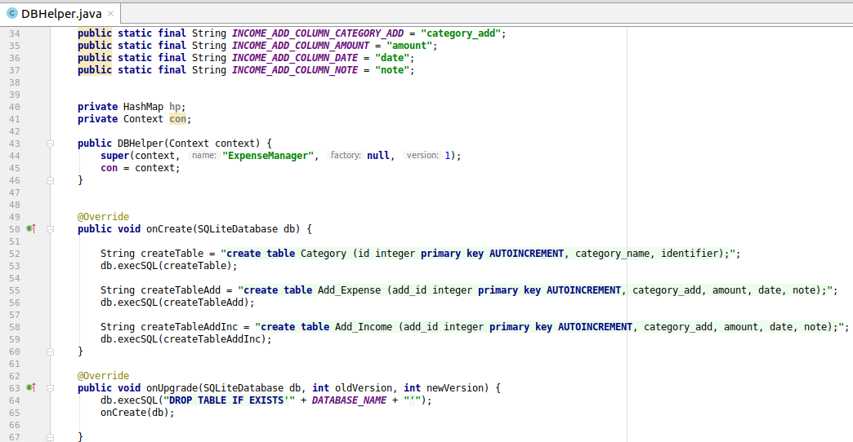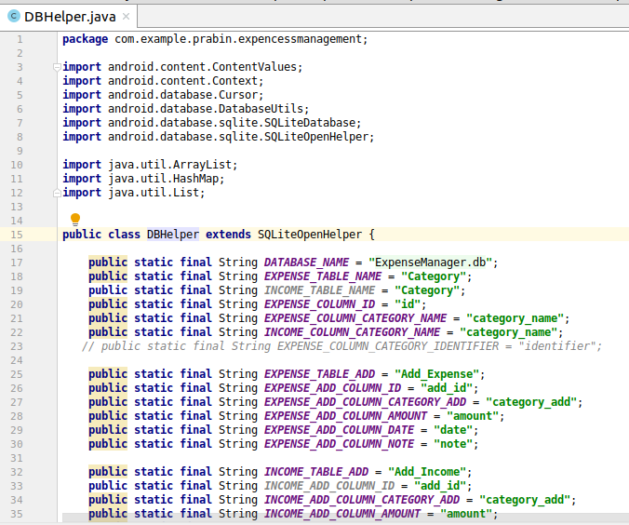**Database:**

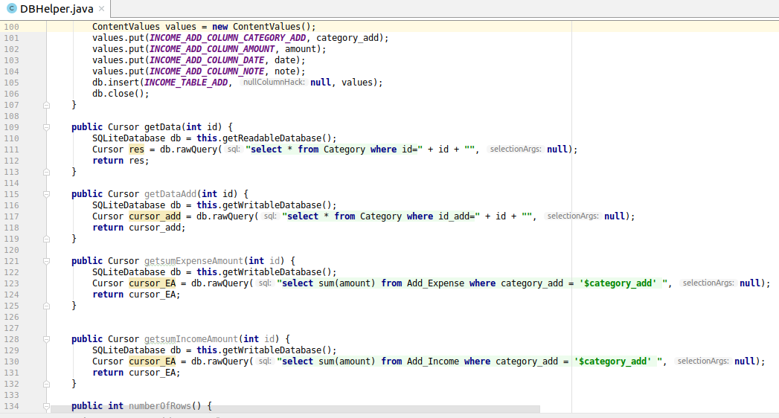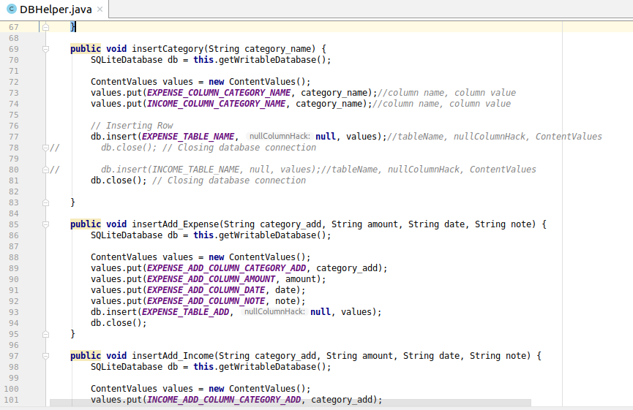

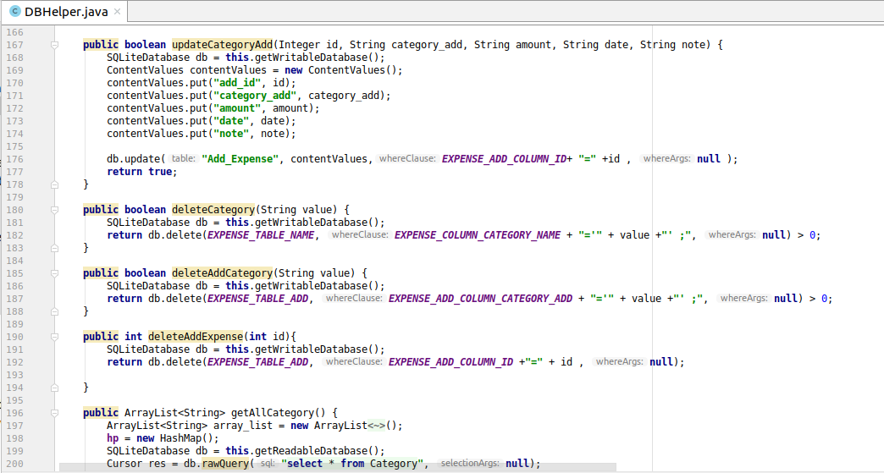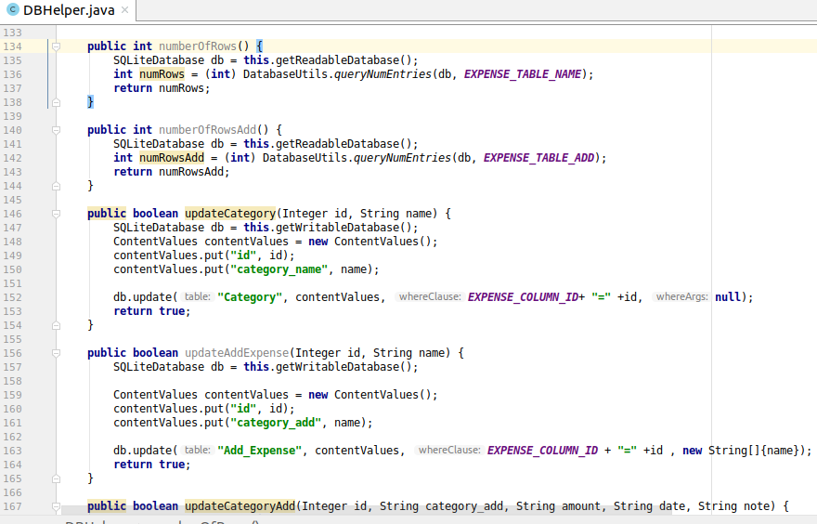

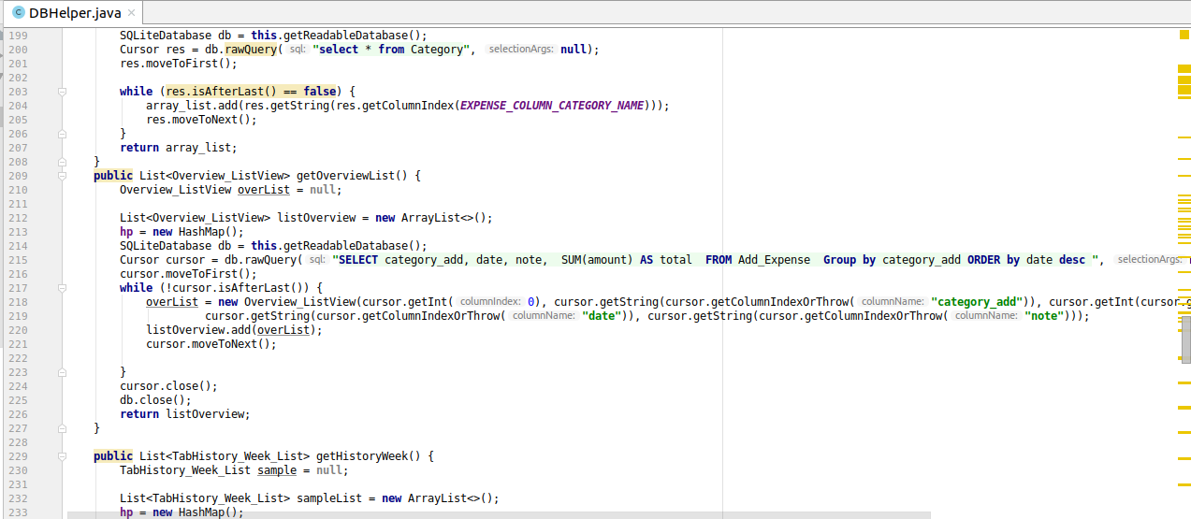

1. **Registration form and their code:**

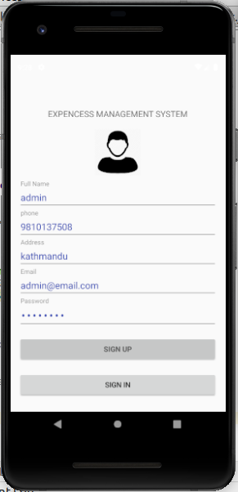

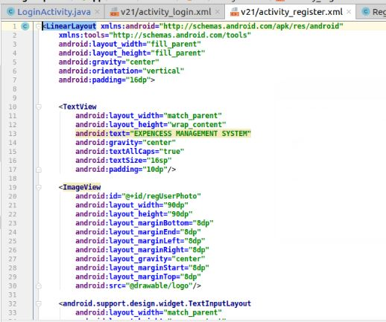 ***XML code for registration:***

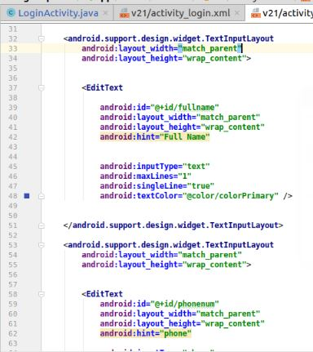

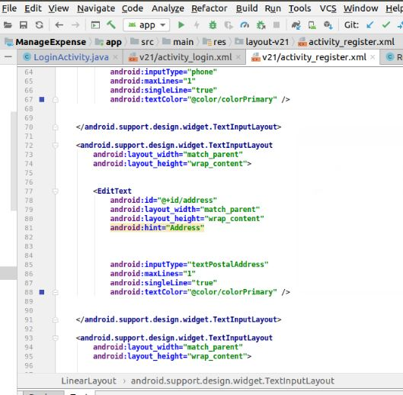

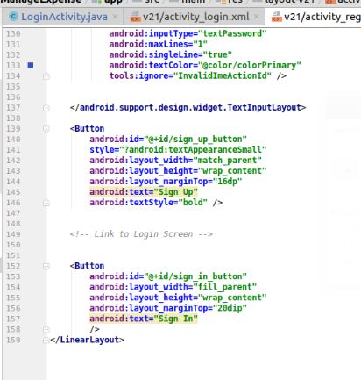

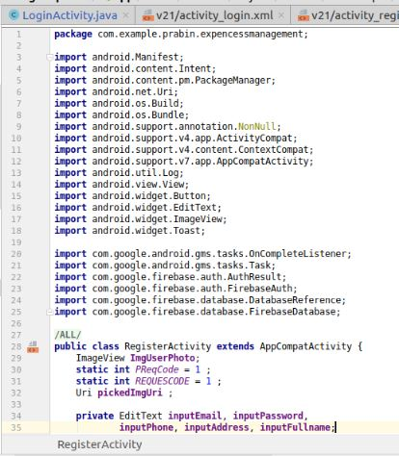 **Code for registration:**

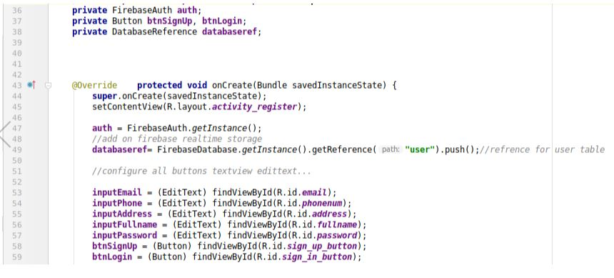

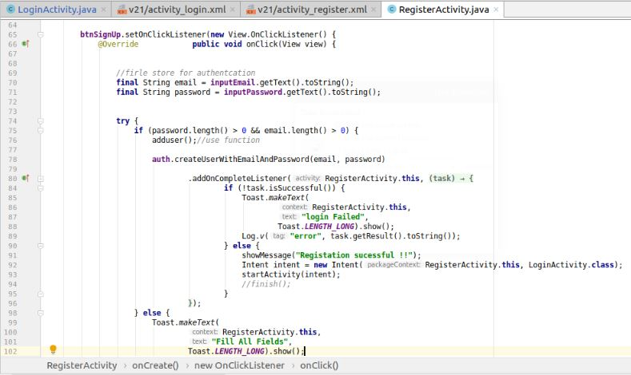

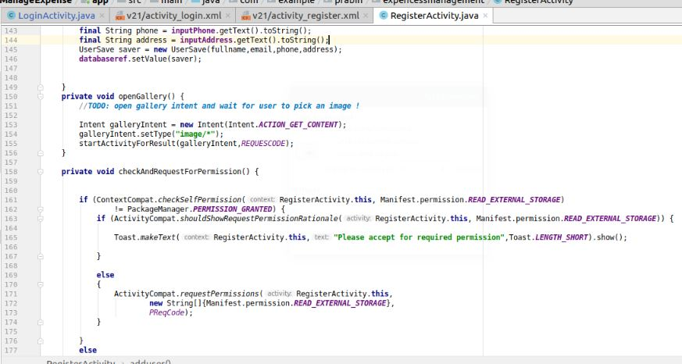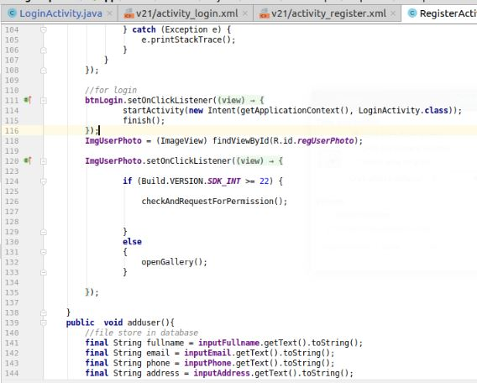

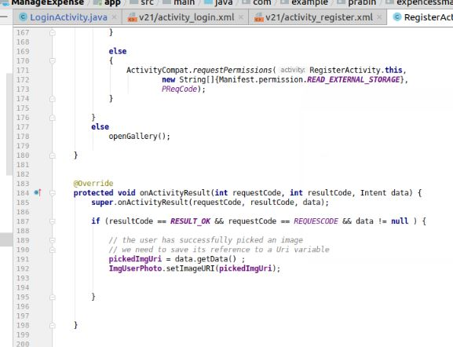

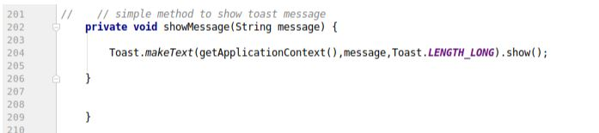

1. **Login form and their code:**

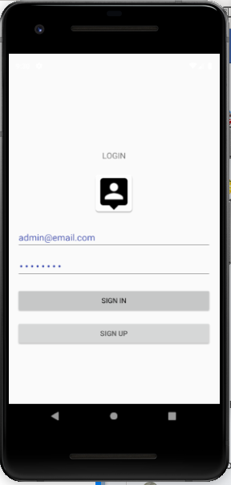

**XML code for login:**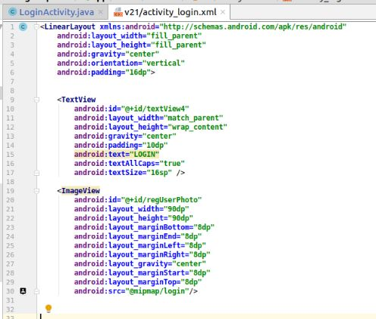

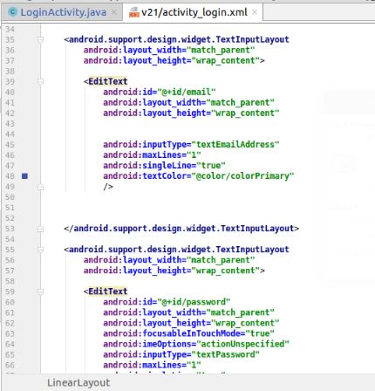

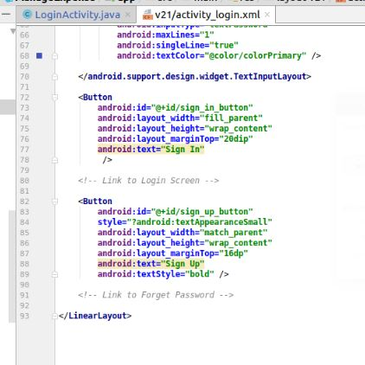

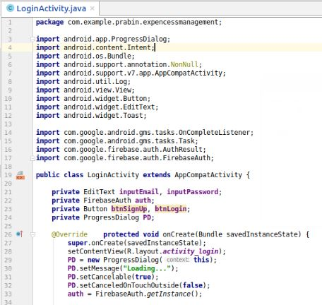 **Code for login:**

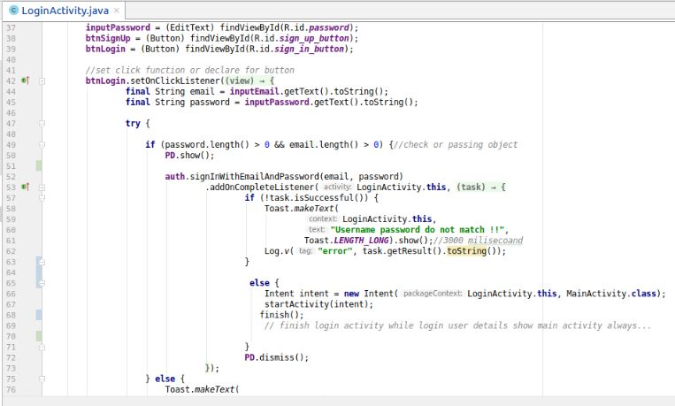

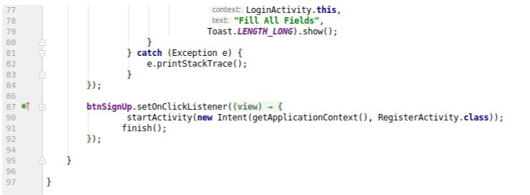

1. **Main Activity form and their code:**

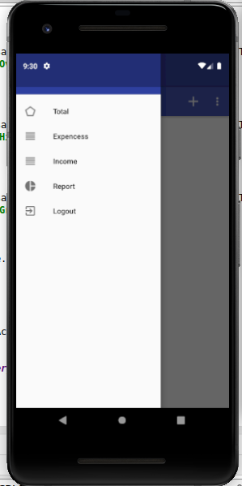

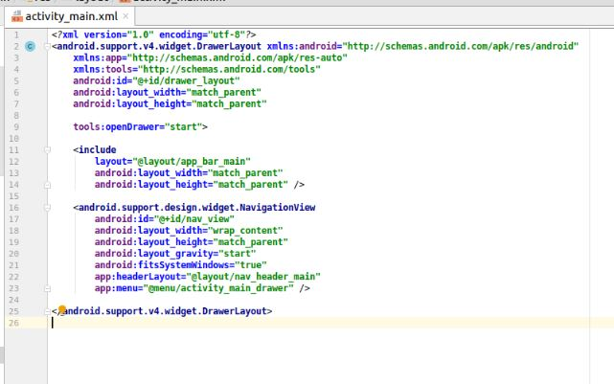**XML code for Main Activity**:

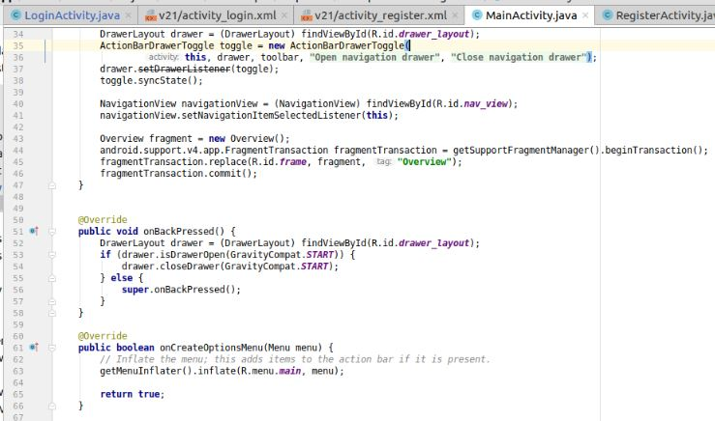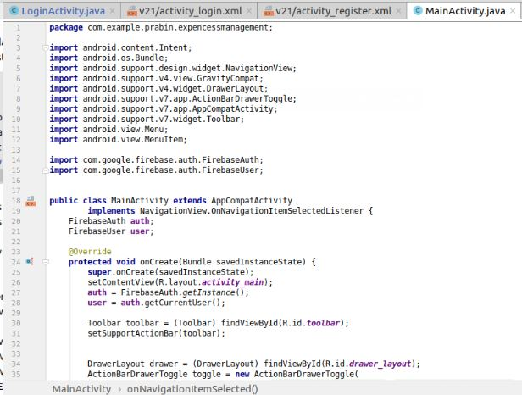**Code for Main Activity:**

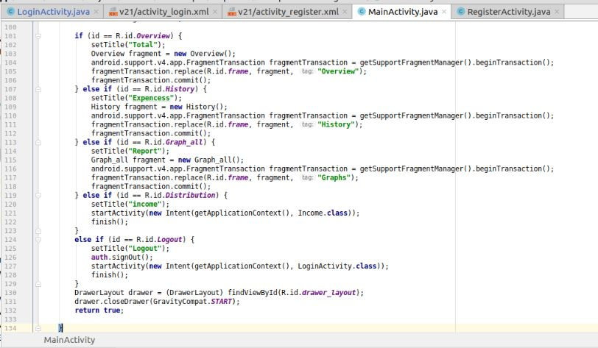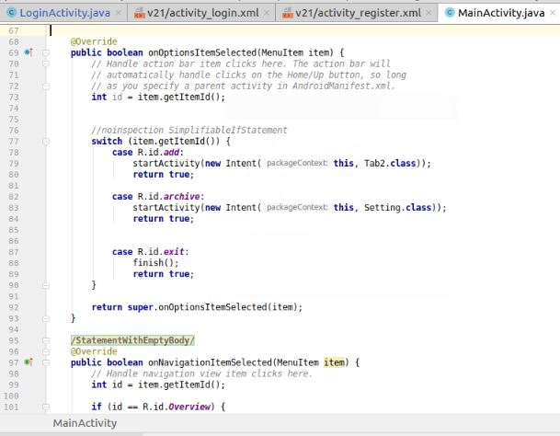

1. **Total expenses and income form with their code**

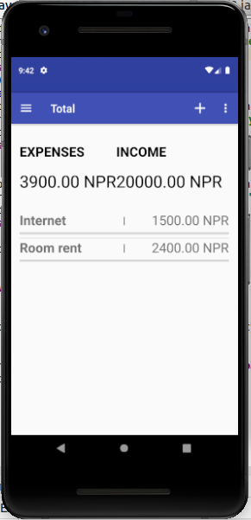

**XML code for total expenses and income:**

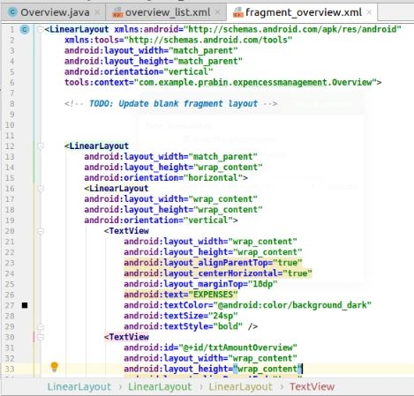

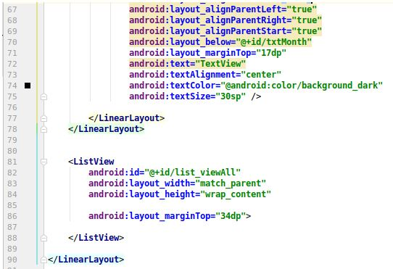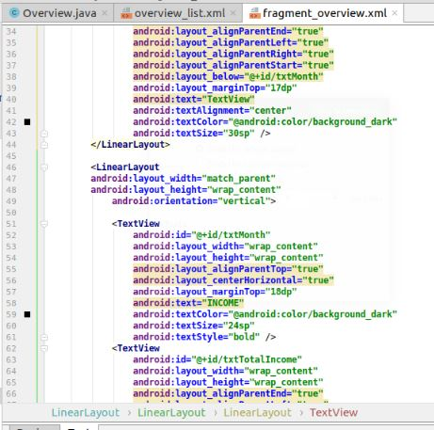

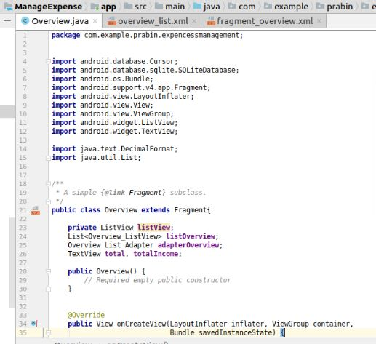**Code for total expenses and income**

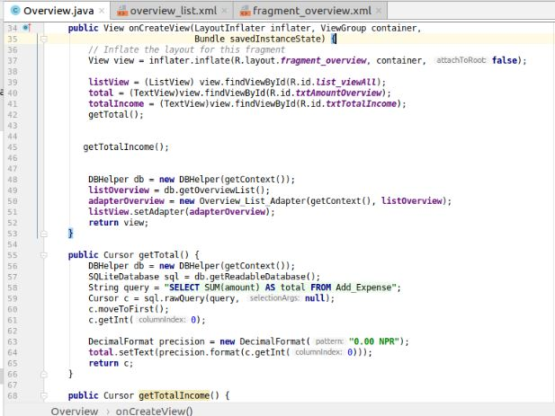

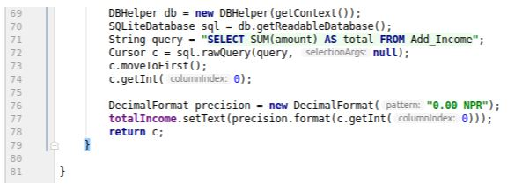

1. **Settings form with their code**

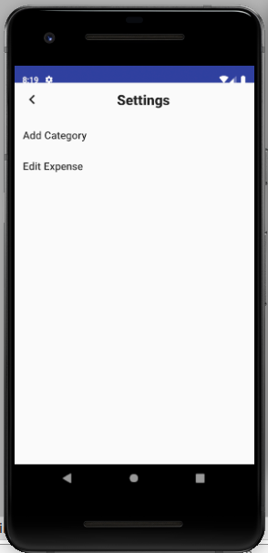

**XML code for setting:**

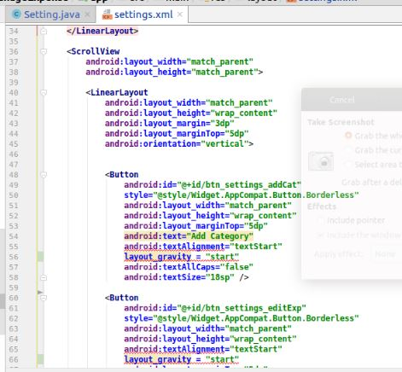

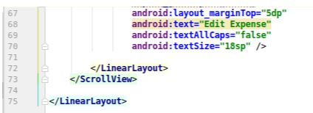

**Code for setting:**

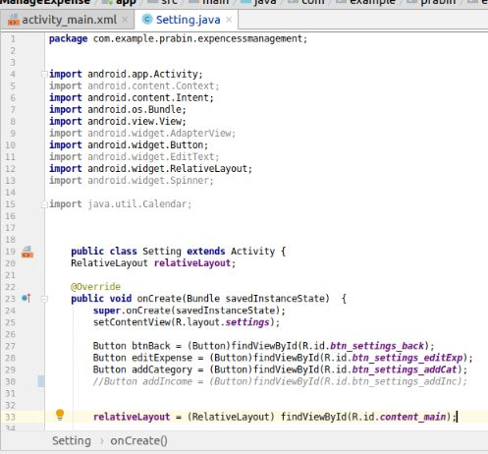

1. **Add category form with their code**

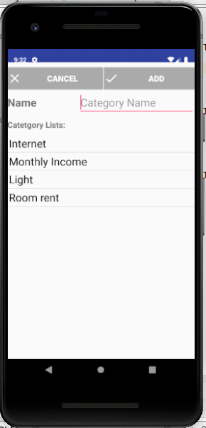**XML Code for add category**:

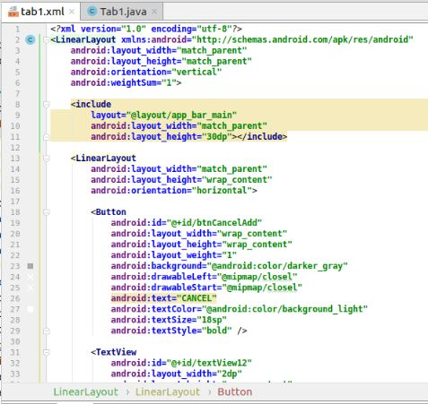

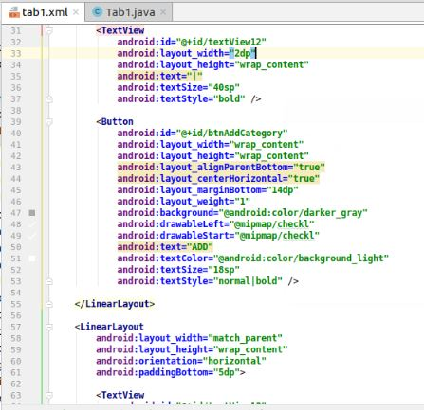

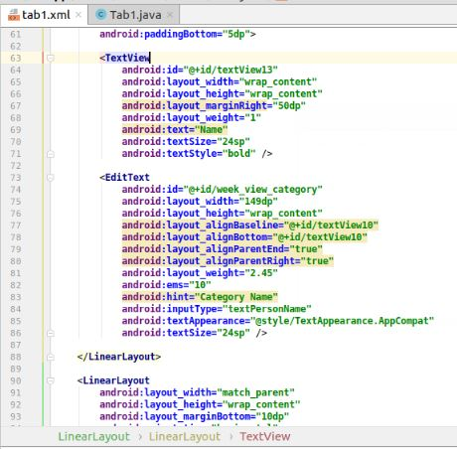

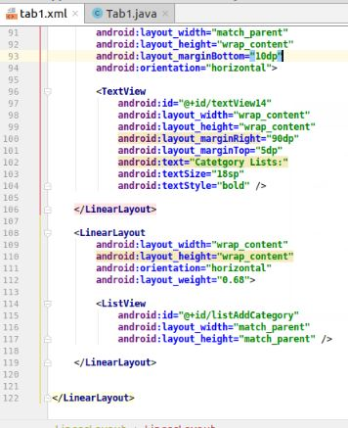

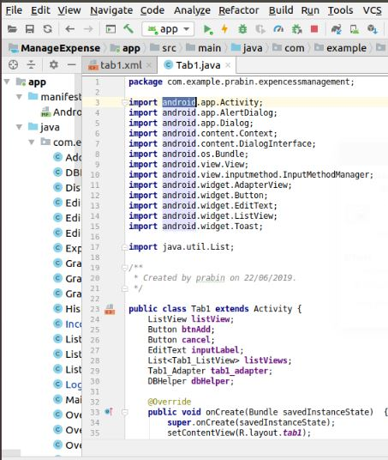 **Code for add category:**

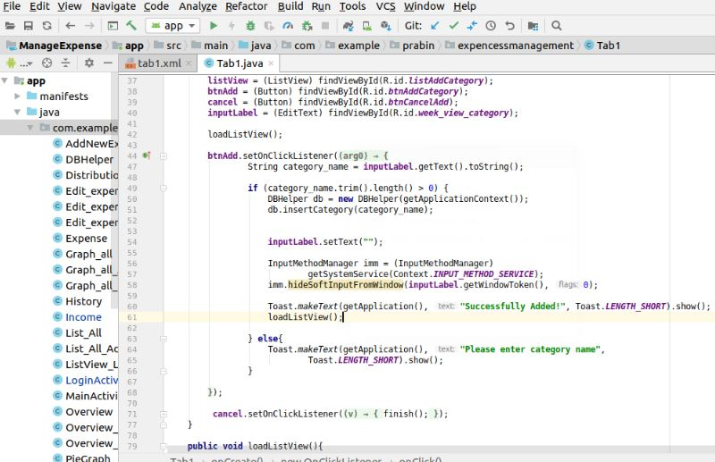

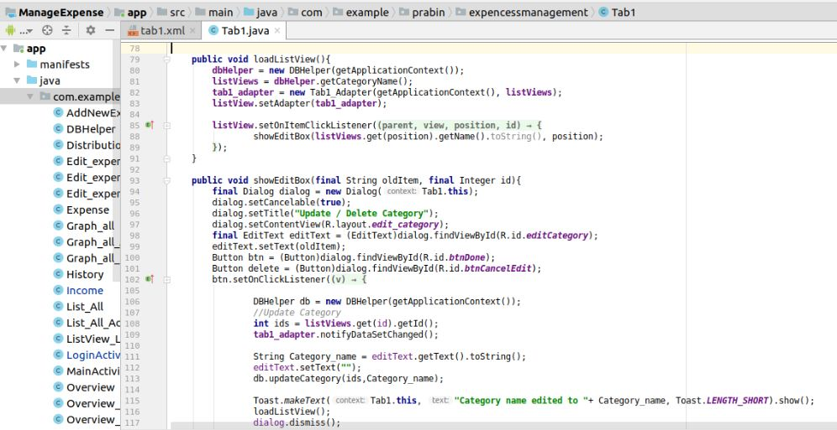

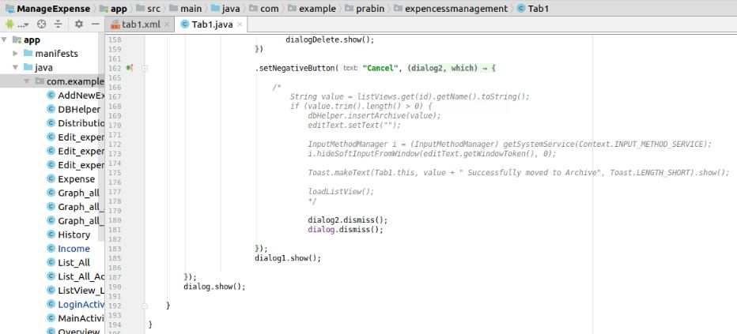

1. **Add income form with their code:**

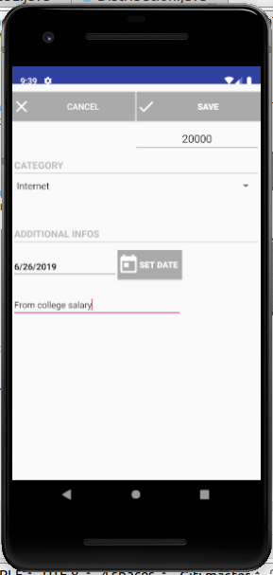

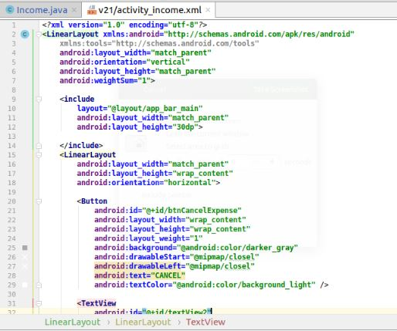**XML code for add income**:

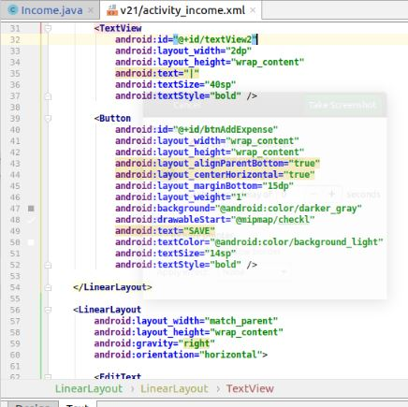

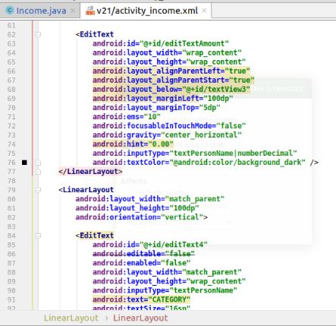

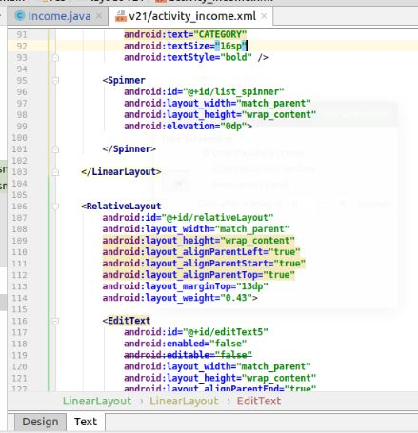

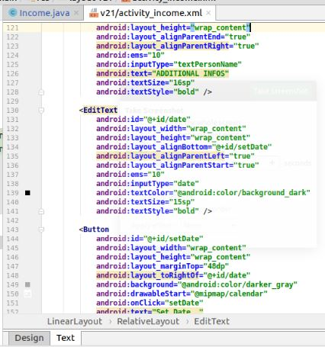

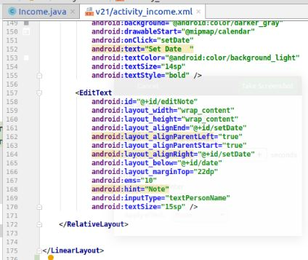

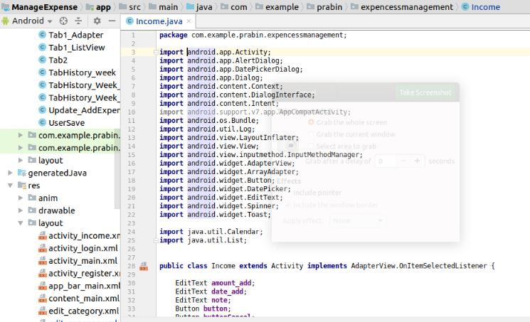**Code for add income:**

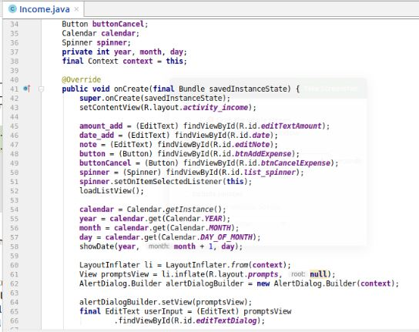

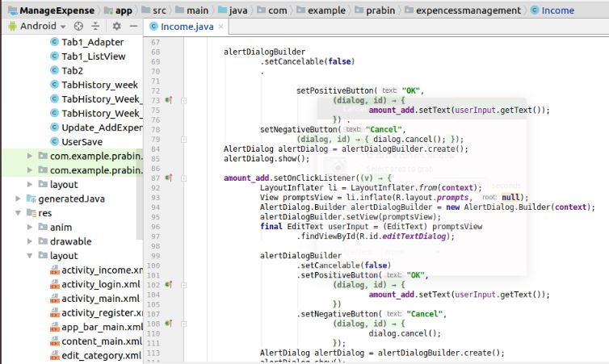

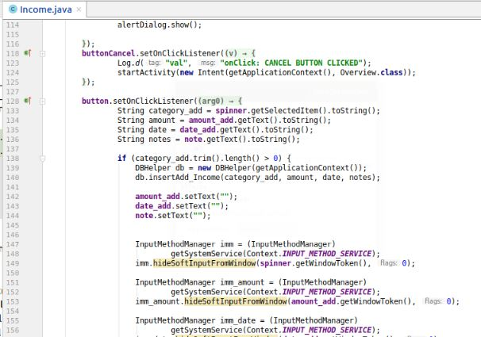

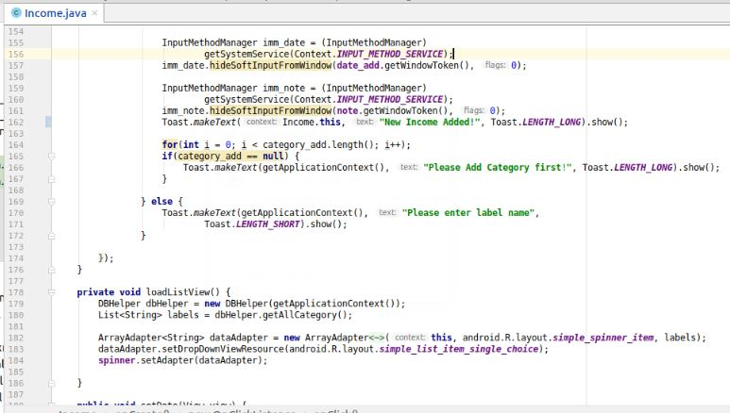

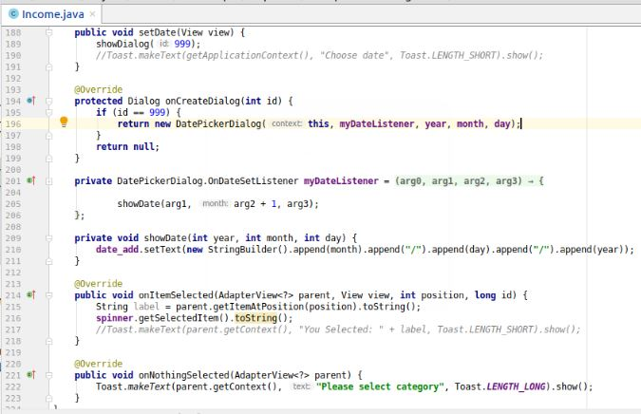

1. **Add expenses form with their code:**

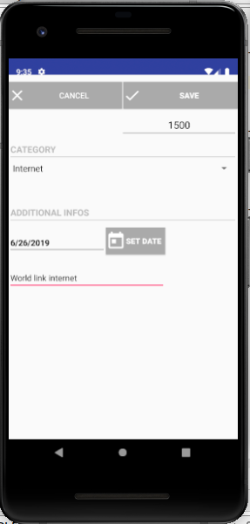

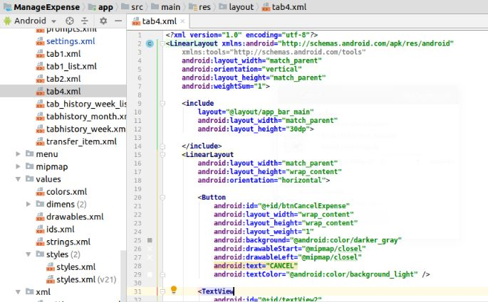**XML code for expenses**:

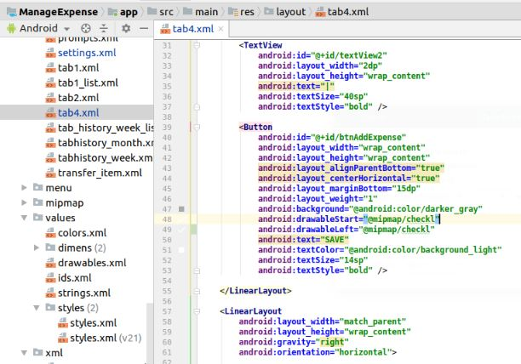

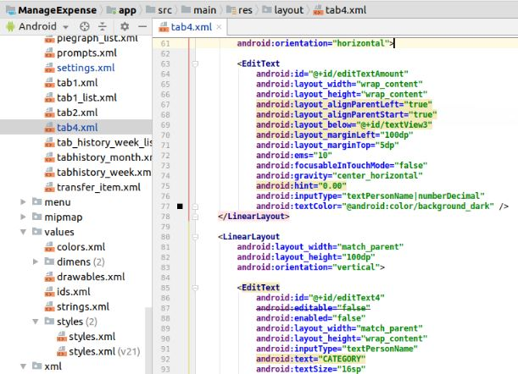

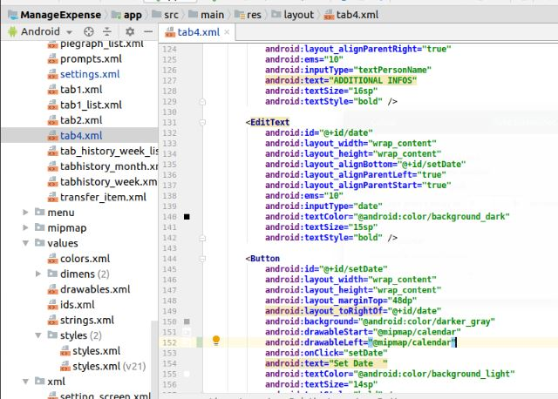

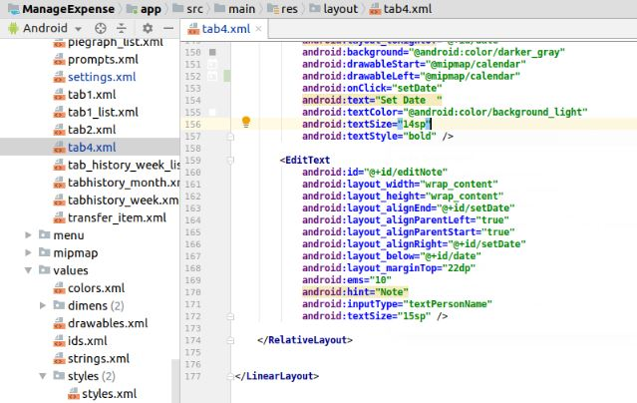

**Code for add expenses:**

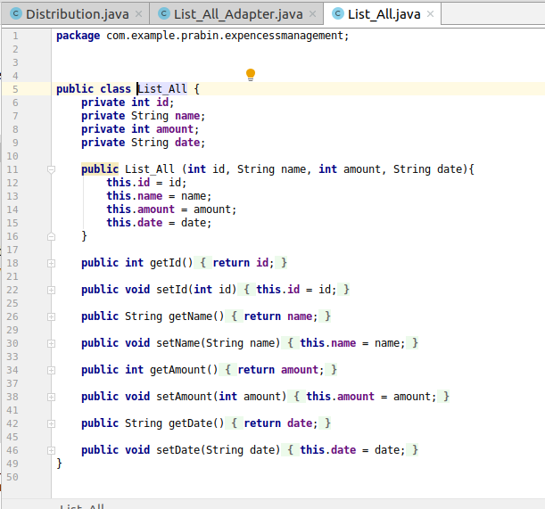

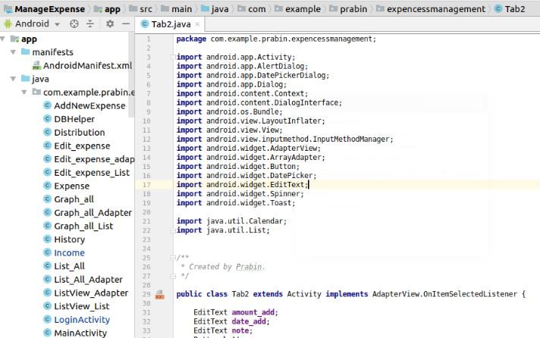

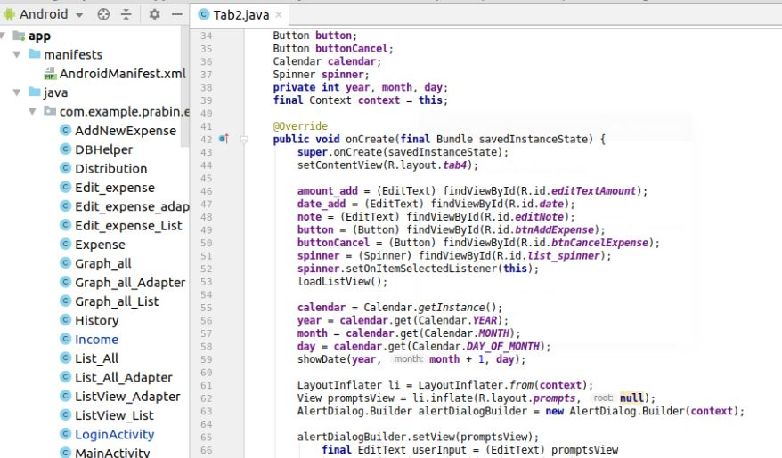

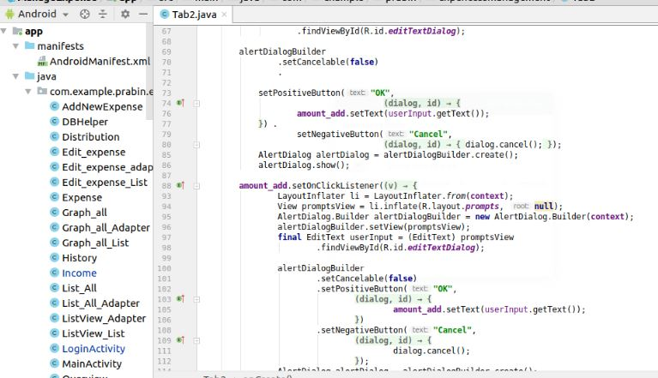

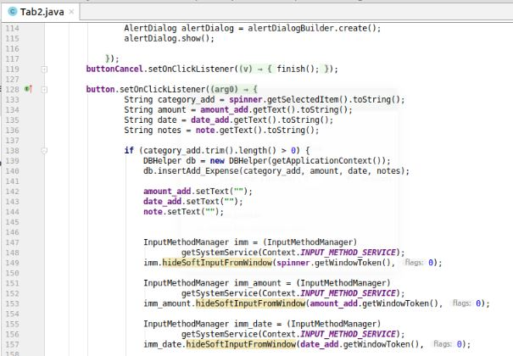

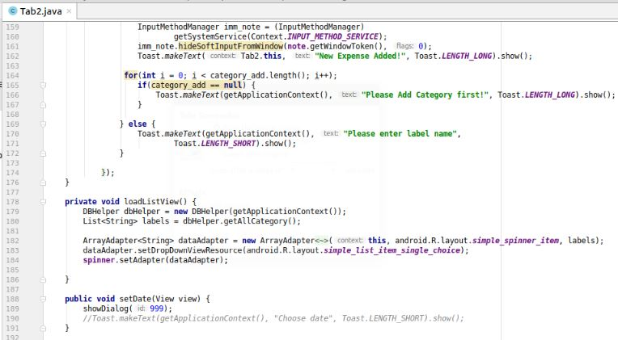

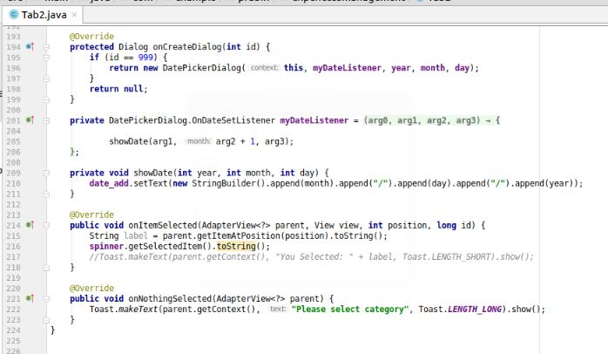

1. **Add expenses list form with their code:**

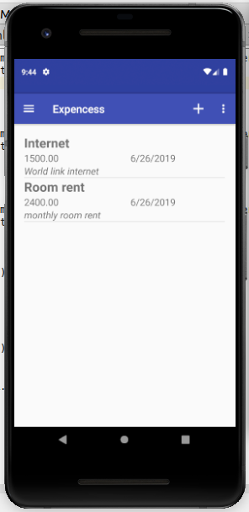

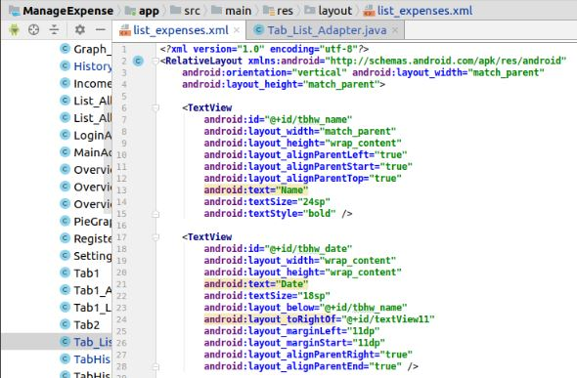**XML Code for list of expenses:**

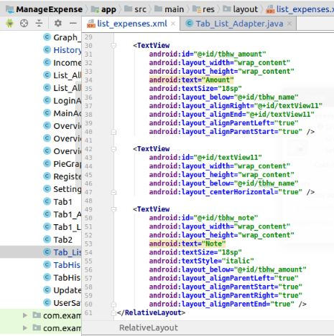

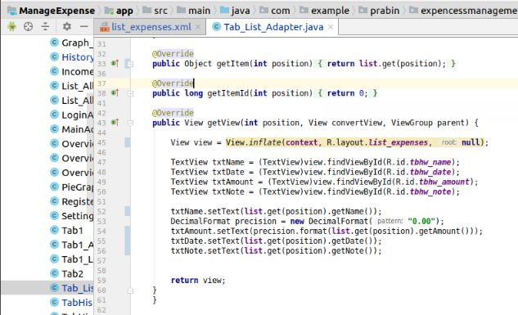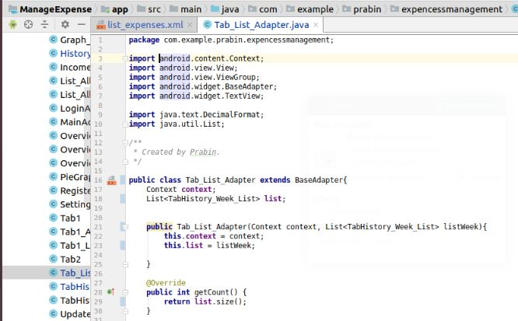**Code for list of expenses:**

1. **Edit expenses form with their code:**

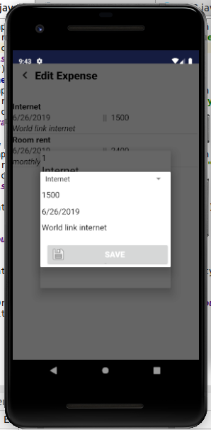

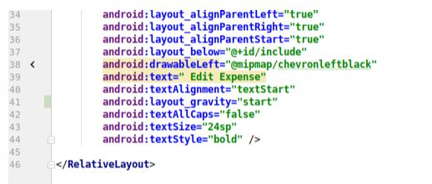**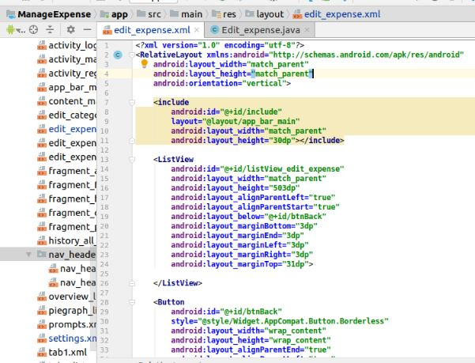XML code for edit expenses**.

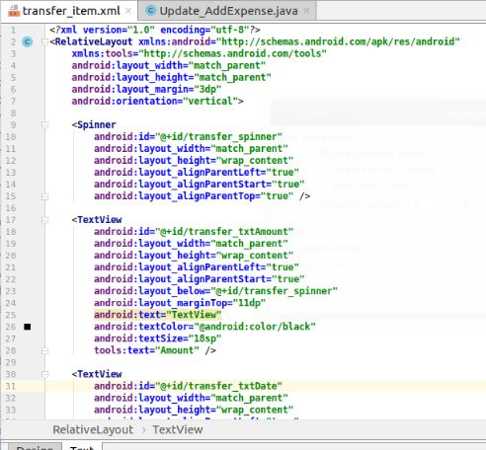

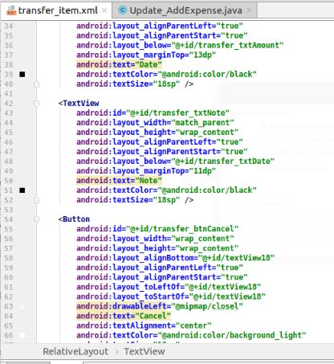

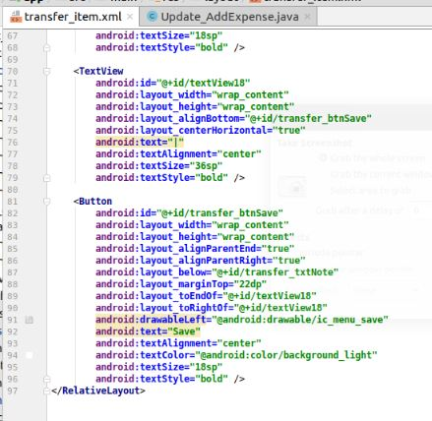

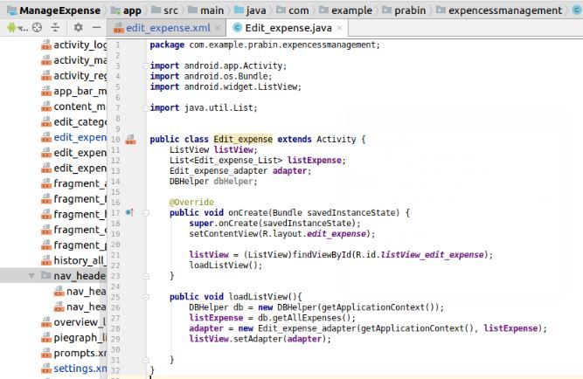**Code for edit expenses**:

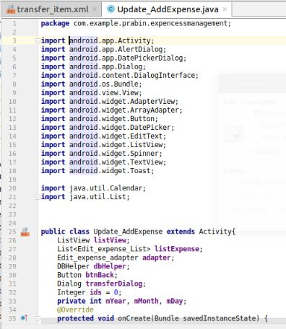

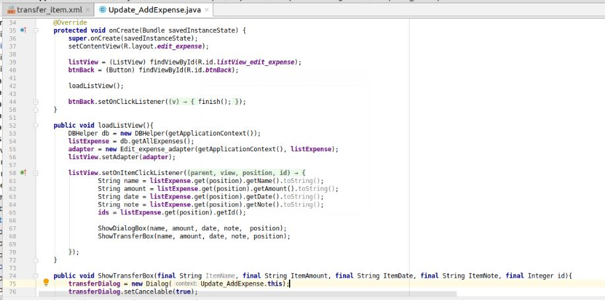

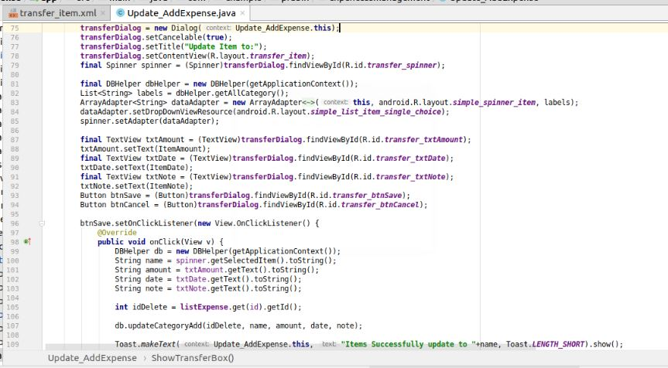

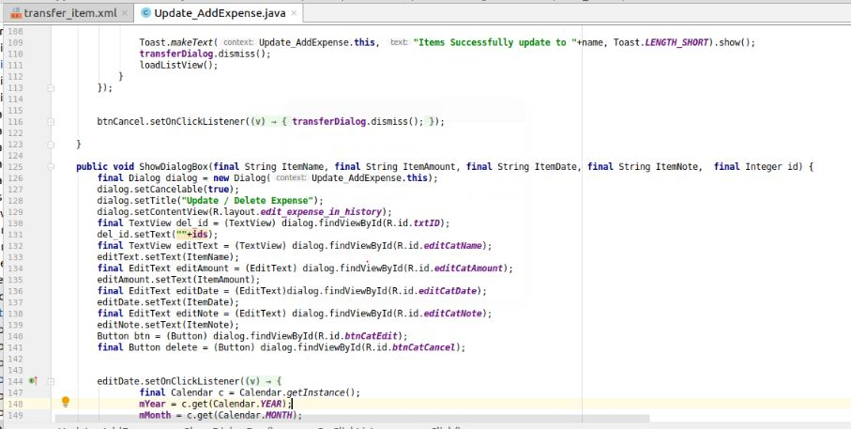

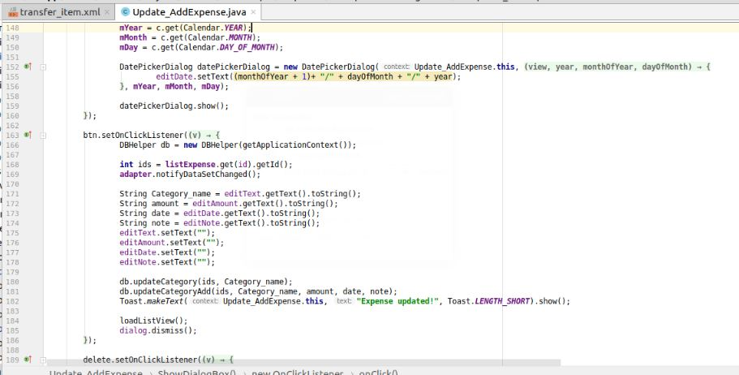

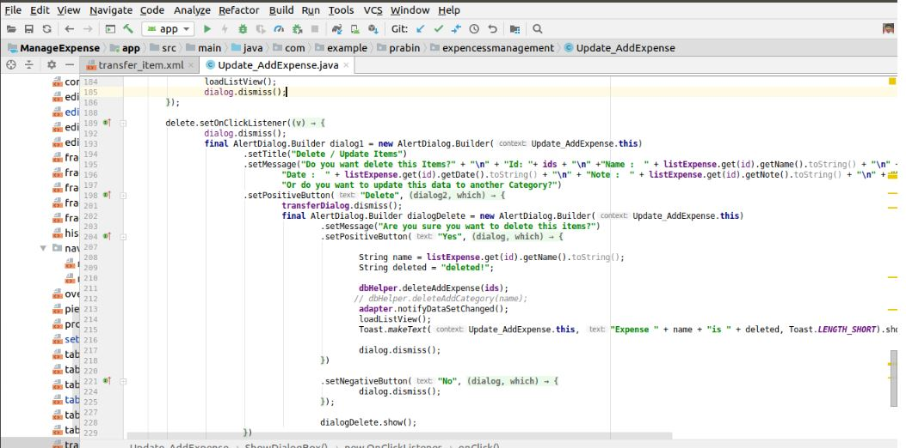

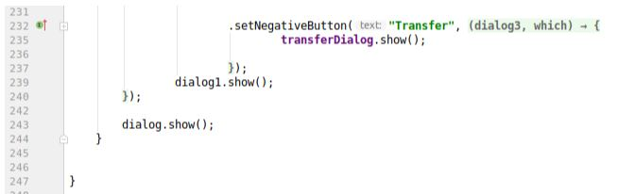

1. **Report form with their code:**

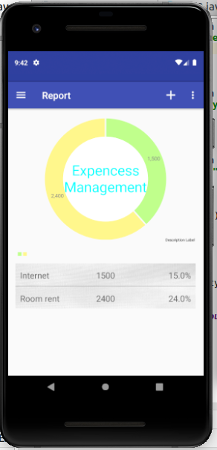

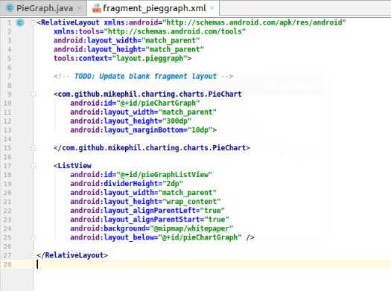**XML code for report**:

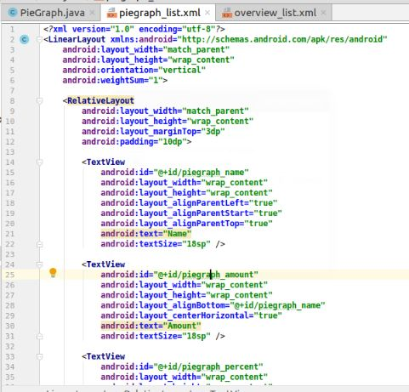

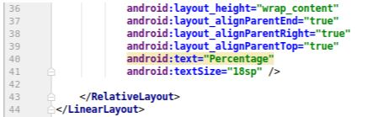

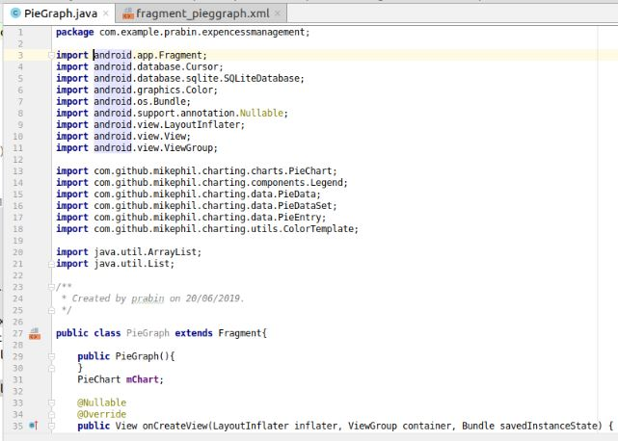**Code for report:**

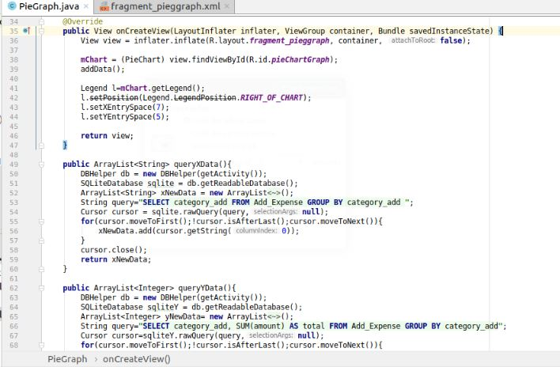

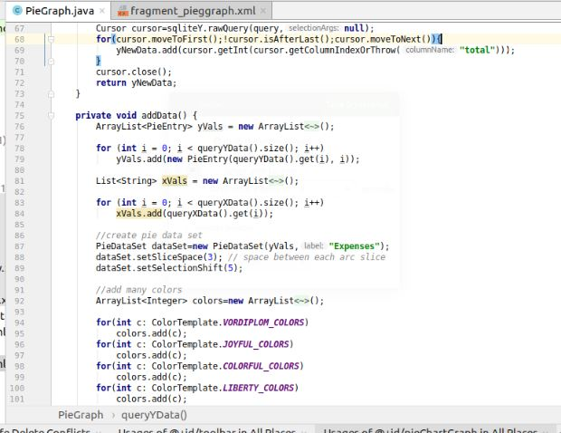

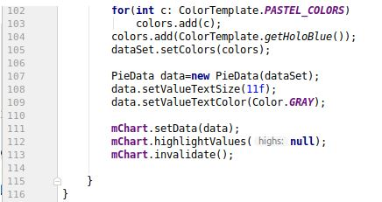

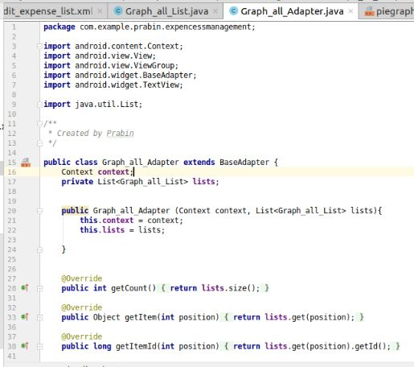

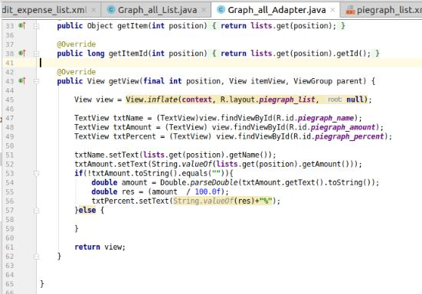

# **Chapter 5 Testing**

Software testing is a process used to identify the correctness, completeness and quality of a developed computer software. It includes a set of activities conducted with the intent of finding errors in software so that it could corrected before the product is released to the end users.

In simple words software testing is an activity to check that the software system is defect free. Software bugs can be expensive or even dangerous.

For this project, I have done black box testing. Some of the black box testing are as given below:

1. 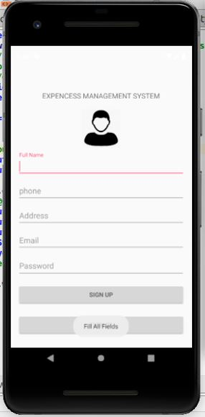**For empty fields registration form**

When we click on SIGN UP button without filling registration form a pop up message displayed on the screen.

**Input:** Empty fields

**Pop up Message**: “Fill All Fields”

**Test case**: Pass

1. 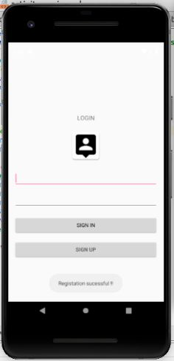**Filling all fields with valid credentials in registration form**

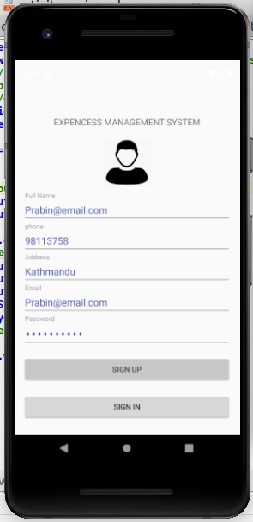

When we fill up the registration form with valid and essential credentials. Then click on “SIGN UP” button a pup up message displayed on the login form of expenses management system.

**Input:** fill up the form with valid credentials

**Pup up Message**: “Registration Successful”

**Test case:** Pass

1. 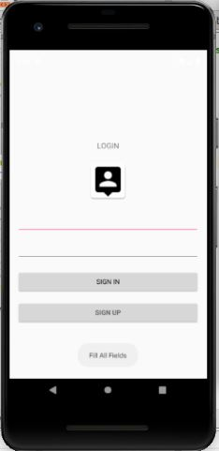**empty fields login form:**

When we click on “SIGN IN” button without filling login form then empty fields message displayed on the display.

**Input:** empty fields

**Pup up Message**: “Fill all fields”

**Test case:** Pass

1. 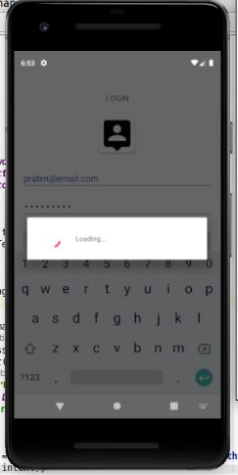**Filling all fields with valid credentials in Login Form:**

When we fill up the login form with valid credentials then a loading message is pop up on the displayed.

**Input:** fill all fields with valid credentials

**Pup up Message**: “loading”

**Test case:** Pass

1. 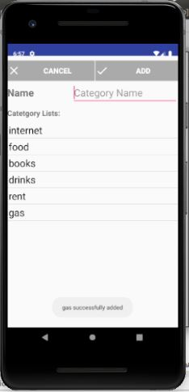**For category Add form:**

Fill up the category name then click on **“ADD”** tab then a pup up message displayed on the screen.

**Input:** enter category name

**Pup up Message**: “category name added successfully”

**Test case:** Pass

1. 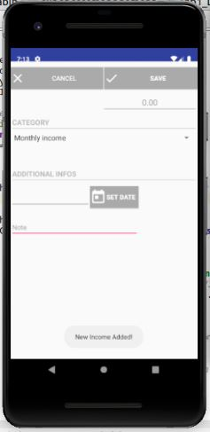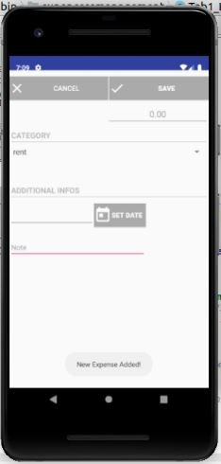**For income and expenses added form:**

Fill up both the form with valid credentials. When we click on “SAVE” button of expenses, form then expenses added message displayed on the screen.

When we click on “SAVE” button of income form then income added message displayed on the screen:

**Input:** fill up form with valid credentials

**Pup up Message**: for income “New Income Added”

For expenses “New Expenses Added”

**Test case:** Pass

# **Chapter 6 Other Project Issues**

I have faces many obstacles to complete my project called expenses management system. There are many issues arises from requirement analysis phase to deployment phase. The main goal is to overcome the obstacles and move forward to achieving goal.

## 6.1 Issues during the Project

During the development of the project, I found following issues:

* **Installation of SDK framework**

During the starting phase of the project, I found the issues while installing SDK framework due to the versions.

Solution: Update versions of SDK framework

* **Issues in code structure**

Due to the inexperienced developer, I faces many issues while coding and developing an application.

Solution: To overcome this issues practice code.

* **Interacting with database**

Database is the place where we store the data of all clients or members. Issues found while interacting with database is that we do not know the command line.

Solution: Proper documentation of command line and practice daily.

* **Issues in Managing time**

Time management for the project is too complicated. Time management for the project based on Gantt chart. According to the Gantt chart, time taken for the certain task declared but not completed on mentioned time.

Solution: Try to complete the task on mentioned time as soon as possible.

* **Lack of knowledge**

From starting phase to Deployment phase of the project I have faces many problems because of lack of knowledge. Problem arises while testing is the main thing that happen because of no knowledge.

Solution: get knowledge from Module leader and practice different programming language.

## 6.2 Risk Management

Risk management is the technique of identifying, assessing and controlling threats to a business using insurance, safety measures etc. The main purpose of risk management is to control or minimize the flow of unexpected risk, extra time and money. To get impact of risk on project we have mathematical calculation i.e.

Impact = Likelihood * Consequences

Likelihood values of risk are as given below:

|  |  |
| --- | --- |
| **Likelihood** | **Value** |
| Low | 1 |
| Medium | 2 |
| High | 3 |

Consequences values of risk are as given below:

|  |  |
| --- | --- |
| **Consequences** | **Value** |
| Very Low | 1 |
| Low | 2 |
| Medium | 3 |
| High | 4 |
| Very High | 5 |

## 

**Risk Table:**

|  |  |  |  |  |  |
| --- | --- | --- | --- | --- | --- |
| **S.N** | **Risks** | **Likelihood** | **Consequences** | **Impact** | **Solution** |
| 1 | Lack of resources | 2 | 3 | 6 | Before to develop application all the resources needed for project should provide. |
| 2 | Operating System failure | 2 | 4 | 8 | Do not overuse computer and provide file backup system. |
| 3 | Problem in flow of electricity | 1 | 5 | 5 | Uninterrupted power supply (UPS) must provide. |
| 4 | Lack of knowledge in users | 3 | 3 | 9 | Provide training to the users before implementation. |
| 5 | Virus, Threats | 2 | 4 | 8 | Regular scheduled scans with the use of installed anti-virus software. |
| 6 | Natural Disaster like Earthquake, flood etc | 1 | 5 | 5 | Implementation of cloud back up system. |
| 7 | Hard drive failure | 1 | 4 | 4 | To prevent from failure reduce data load and provide back-up system. |
| 8 | Lack of physical memory | 2 | 3 | 6 | Sufficient RAM and good processor. |

## 6.3 Configuration Management

Configuration Management is the process for administrative activities concerned with the creation, maintenance, control change and quality control of the project. It helps to build the effectiveness, execution and dependability of the project. To effectively accessible from everywhere, files managed in sorted out structure.

The Username, GitHub Profile and Repository of my GitHub account is:

**Username: PrawinAyadi**

**GitHub Profile:** <https://github.com/PrawinAyadi>

The repository link of my GitHub account: <https://github.com/PrawinAyadi/EMS>

Below information shows the directory structure of project:

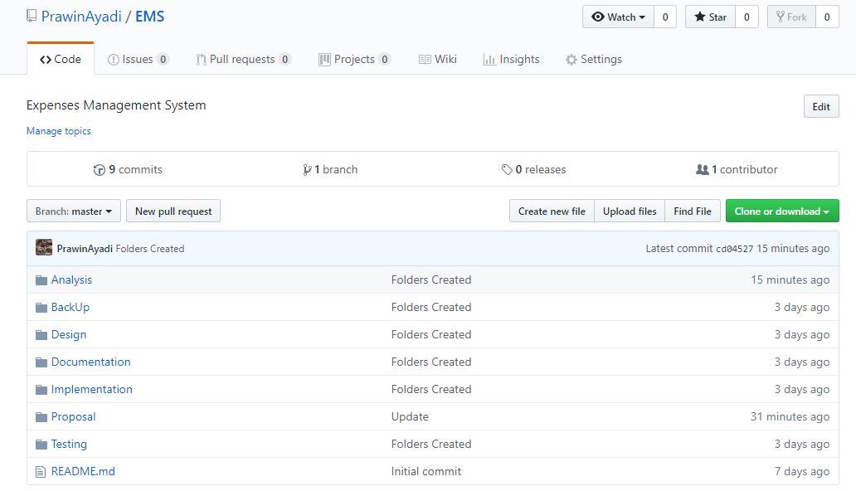

Screenshot 28: Location for Git Push

In GitHub account, I have created a total seven folder i.e. Analysis, Design, Implementation, Testing, Documentation, Proposal and Backup. The analysis, design, implementation, testing portion of the project uploaded in respective folder. Proposal of the complete project uploaded in proposal folder and documentation of the project i.e. final report uploaded in documentation folder. All the files associated with project comes under backup folder. This also helps in future use also if the file has deleted.

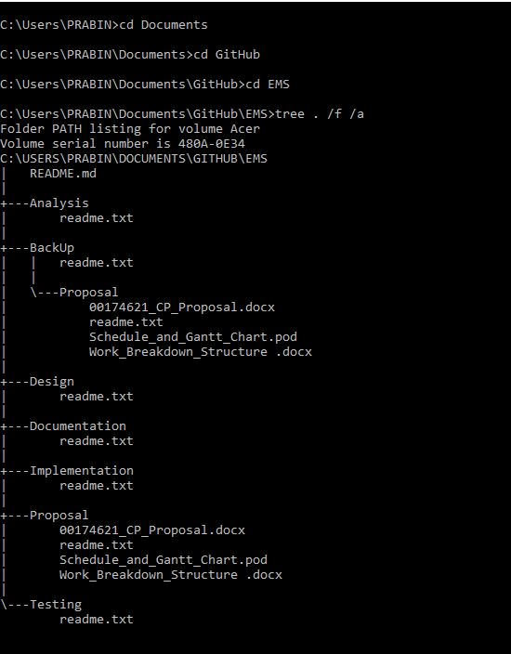

## 6.4 Future Work

The project that I have developed has limited features due to the limited time. Most of the features of the project not implemented while developing. Other some future work makes an application improved to use. Features implemented in future provide an application better to use.

Some of the future work for the project are as given below:

* **Integration of credit card**

Integration of credit card helps in easily payment that makes an application better to use. Easily payment of water, light, waste from this application.

* **UI design must be better.**
* **Implementation of different country language i.e. Nepali, French, English etc**
* **Notification for repeated activities like monthly internet payment, light bill payment and many other activities that repeated after each month.**



## 6.5 User Manual

**For Registration Form:**

* User fill up the registration form with valid credentials.
* To register click on **“SIGN UP”** button.
* After click on **“SIGN UP”,** button successful registration message displayed on the screen.

**For Login Form:**

* Fill up the login form with valid credentials.
* Click on “**SIGN IN**” button to enter into the system.
* After click on “**SIGN IN**” button “**loading**” message displayed on the screen.



**For Dashboard Form:**

* Click on specific tab to open the specific form.
* To open expenses form click on expenses tab
* To open income form click on income tab
* Click on Total tab to view the total income and expenses
* Click on Report tab to know the expenses report
* To get out from the system click on Logout tab.

**For Setting Form**:

* Setting form contain two tab i.e. Add Category and Edit Expenses
* Click on Add Category tab to open Category form.
* Click on Edit Expense tab to open edit expenses form



**For Add Category Form:**

* Fill the category name space with category name.
* To add category click on “ADD” button
* To cancel category click on “CANCEL” button

**For Income and Expenses Form:**

* Enter amount, select category, select date, write short note on expense and click on save button to save.
* Enter amount, select category, select date, write short note on income and click on save button to save.

# **Conclusion:**

The main purpose of my project is to inspire the clients to lessen their spending. User can easily manage their expenses with the use of this application. To control or maintain the flow of expenses user can add their salary and daily expenses and it helps to manage the cash flow. This application is a valuable resource for cost saving, auditing and financial analysis. Error caused by a paper process and delay in reports reduced with the use of this application.

# **References**

geeksforgeeks.org, 2019. *geeksforgeeks..* [Online]   
Available at: https://www.geeksforgeeks.org/unified-modeling-language-uml-sequence-diagrams/

Ivory-Ndiaye, P. M. Y., 2018. *Visual Paradigm.* [Online]   
Available at: https://www.visual-paradigm.com/guide/uml-unified-modeling-language/what-is-use-case-diagram/

LLC, M. A. M., 2018. *modernanalyst.* [Online]   
Available at: https://www.modernanalyst.com/Careers/InterviewQuestions/tabid/128/ID/1433/What-is-a-Context-Diagram-and-what-are-the-benefits-of-creating-one.aspx

tutorialspoint.com, 2019. *tutorialspoint.* [Online]   
Available at: https://www.tutorialspoint.com/uml/uml_activity_diagram